**AWS Region**

AWS Regions are large and widely dispersed into separate geographic locations, i.e region are geographic location, In AWS Region data centres (AZ ) are clustered..

**Each region has many availability zone(usually 3, min 3 and max 6)**

**Availability Zone**

Availability Zones are distinct locations within an AWS Region that are engineered to be isolated from failures in other Availability Zones.

In a region each availability zone are isolated in power supply, colling and interconnected by high bandwidth link.

An Availability Zone (AZ) is one or more discrete data centres with redundant power, networking, and connectivity in an AWS Region

Between two AZs traffic is encrypted. ---- Sample Paper

**AWS Local Zones:**

AWS Local Zones allow you to use select AWS services, like compute and storage services, ***more closer to end-users***, providing them very low latency access to the applications running locally.

Applications which require single-digit millisecond latencies to your end-users, latency-sensitive applications

In Simple terms, AWS Local Zones are a type of infrastructure deployment that places compute, storage, database, and other select AWS services close to large population and industry centres.

**Edge location:**

*Edge locations are endpoints for AWS which are used for caching content and used as Content delivery network (CDN).*

Requests going to either one of these services will be routed to the nearest edge location automatically. This allows for low latency no matter where the end user is located.



**Six advantages of Cloud Computing**

We have below six advantages of using cloud computing instead of traditional(on-premise) computing-

1. **Trade fixed expense for variable expense** – Instead of having to invest heavily in data centres and servers before you know how you’re going to use them, you can pay only when you consume computing resources, and pay only for how much you consume.
2. **Benefit from massive economies of scale** – By using cloud computing, you can achieve a lower variable cost than you can get on your own. Because usage from hundreds of thousands of customers is aggregated in the cloud, providers such as AWS can achieve higher economies of scale, which translates into lower pay as-you-go prices.
3. **Stop guessing capacity** – Eliminate guessing on your infrastructure capacity needs. When you make a capacity decision prior to deploying an application, you often end up either sitting on expensive idle resources or dealing with limited capacity. With cloud computing, these problems go away. You can access as much or as little capacity as you need, and scale up and down as required with only a few minutes’ notice.
4. **Increase speed and agility** – In a cloud computing environment, new IT resources are only a click away, which means that you reduce the time to make those resources available to your developers from weeks to just minutes. This results in a dramatic increase in agility for the organization, since the cost and time it takes to experiment and develop is significantly lower.
5. **Stop spending money running and maintaining data centres** – Focus on projects that differentiate your business, not the infrastructure. Cloud computing lets you focus on your own customers, rather than on the heavy lifting of racking, stacking, and powering servers.
6. **Go global in minutes** – Easily deploy your application in multiple regions around the world with just a few clicks. This means you can provide lower latency and a better experience for your customers at minimal cost.

**What is IAM**

AWS Identity and Access Management (IAM) is a web service that helps you securely control access to AWS resources that will be used by any users.

You use IAM to control (read access, write access etc ) who is authenticated (signed in) and authorized (has permissions) to use resources. It facilitates AWS SSO (Single Sign-ON)

**IAM: Users & Groups**

* **IAM** = Identity and Access Management, Global service
* Root account created by default, should not be used or shared
* Users are people within your organization, and can be grouped
* Groups only contain users, not other groups
* Users can belong to multiple groups

**IAM: Permissions**

* Users or Groups can be assigned JSON documents called policies
* These policies define the permissions of the users
* In AWS you apply the least privilege principle: don’t give more permissions than a user needs

**IAM Policies inheritance**

*A policy is an object in AWS that, when associated with an entity or resource, defines their permissions*



**IAM Policies Structure**

* **Consists of**

1. **Version**: policy language version, always include “2012-10-17”
2. **Id**: an identifier for the policy (optional)
3. **Statement**: one or more individual statements (**required**)

* **Statements consists of**

1. **Sid**: an identifier for the statement (optional)
2. **Effect**: whether the statement allows or denies access (Allow, Deny) -- Mandatory
3. **Principal**: account/user/role to which this policy applied to
4. **Action**: list of actions this policy allows or denies ----------------------- -- Mandatory
5. **Resource**: list of resources to which the actions applied to
6. **Condition**: conditions for when this policy is in effect (optional)

Example:



**IAM – Password Policy**

* Strong passwords = higher security for your account
* Allow all IAM users to change their own passwords
* Require users to change their password after some time (password expiration)
* Prevent password re-use
* In AWS, you can setup a password policy

1. Set a minimum password length
2. Require specific character types:
3. including uppercase letters
4. lowercase letters
5. numbers
6. non-alphanumeric characters

**IAM Policy**

A policy is an object in AWS that, when associated with an entity or resource, defines their permissions

**IAM Roles for Services**

**Entities you create and assign specific permissions, that allow trusted identities such as workforce identities and applications to perform actions in AWS**

* IAM role **can be created for services, users, web entity etc**(try to create will get all )
* Some AWS service will need to perform actions on your behalf
* To do so, we will assign permissions to AWS services with IAM Roles
* Common roles:

1. EC2 Instance Roles
2. Lambda Function Roles ( read, write , put etc data into S3 bucket)
3. Roles for CloudFormation

**IAM Security Tools**

* *IAM Credentials Report* (account-level).
  + A report that lists all your account's users and the status of their various credentials.
* *IAM Access Advisor* (user-level).
  + Access advisor shows the service permissions granted to a user and when those services were last accessed.
* You can use this information to revise your policies.

**IAM Guidelines & Best Practices**

* Do not use the root account except for AWS account setup
* One physical user = One AWS user
* **Assign users to groups** and assign permissions to groups
* Create a **strong password policy**
* Use and enforce the use of **Multi Factor Authentication (MFA)**
* Create and use Roles for giving permissions to AWS services
* Use Access Keys for Programmatic Access (CLI / SDK)
* Audit permissions of your account with the IAM Credentials Report
* **Never share IAM users & Access Keys**

**Shared Responsibility Model for IAM**

| **AWS** | **YOU** |
| --- | --- |
| Infrastructure (global network security) | Users, Groups, Roles, Policies management and monitoring |
| Configuration and vulnerability analysis | Enable MFA on all accounts |
| Compliance validation | Rotate all your keys often, Use IAM tools to apply appropriate permissions, Analyze access patterns & review permissions |

## Multi Factor Authentication - MFA

* Users have access to your account and can possibly change configurations or delete resources in your AWS account
* You want to protect your Root Accounts and IAM users
* MFA = password you know + security device you own
* Main benefit of MFA: if a password is stolen or hacked, the account is not compromised

## MFA devices options in AWS

* ***Virtual MFA device*** (Support for multiple tokens on a single device.)
  + Google Authenticator (phone only)
  + Authy (multi-device)
* ***Universal 2nd Factor (U2F) Security Key*** (Support for multiple root and IAM users using a single security key)
  + YubiKey by Yubico (3rd party)
* Hardware Key Fob MFA Device
* Hardware Key Fob MFA Device for AWS GovCloud (US)

## How can users access AWS ?

* To access AWS, you have three options:
  + AWS Management Console (protected by password + MFA)
  + AWS Command Line Interface (CLI): protected by access keys
  + AWS Software Developer Kit (SDK) - for code: protected by access keys
* Access Keys (Access Key ID and Secret Access Key) are generated through the AWS Console
* Users manage their own access keys
* Access Keys are secret, just like a password. Don’t share them
* Access Key ID ~= username
* Secret Access Key ~= password

## What’s the AWS CLI?

* A tool that enables you to interact with AWS services using commands in your command-line shell
* Direct access to the public APIs of AWS services
* You can develop scripts to manage your resources
* It’s open-source <https://github.com/aws/aws-cli>
* Alternative to using AWS Management Console

## What’s the AWS SDK?

* AWS Software Development Kit (AWS SDK)
* Language-specific APIs (set of libraries)
* Enables you to access and manage AWS services programmatically
* Embedded within your application
* Supports
  + SDKs (JavaScript, Python, PHP, .NET, Ruby, Java, Go, Node.js, C++)
  + Mobile SDKs (Android, iOS, …)
  + IoT Device SDKs (Embedded C, Arduino, …)
* Example: AWS CLI is built on AWS SDK for Python

**AWS CloudShell**

AWS CloudShell is a browser-based shell that you can use to manage AWS services using the AWS Command Line Interface (AWS CLI) and a range of pre-installed development tools

## IAM Section – Summary

* **Users:** mapped to a physical user, has a password for AWS Console
* **Groups:** contains users only
* **Policies:** JSON document that outlines permissions for users or groups
* **Roles:** for EC2 instances or AWS services
* **Security:** MFA + Password Policy
* **AWS CLI:** manage your AWS services using the command-line
* **AWS SDK:** manage your AWS services using a programming language
* **Access Keys:** access AWS using the CLI or SDK
* **Audit:** IAM Credential Reports & IAM Access Advisor
* IAM Credentails Report(Account-level)

**#################**

**# IAM Security Tool #**

**#################**

**IAM Credentials Report(Account-level)**

A report that lists all your account's user and the status of their various credentials.

**IAM Credentials Report (User-level)/ IAM Access advisor**

* Access advisor shows the service permission granted to a user and when those services were last accessed.
* You can use this infromation to revise your policies.

**Temporary security credentials in IAM (AWS STS -- global service)**

You can use the AWS Security Token Service (AWS STS) to create and provide trusted users with **temporary**, **limited-privilege** security credentials that can control access to your AWS resources. Temporary security credentials work almost identically to long-term access key credentials, with the following differences:

* Temporary security credentials are short-term, as the name implies. They can be configured to last for anywhere from a few minutes to several hours.
* Temporary security credentials are not stored with the user but are generated dynamically and provided to the user when requested. When (or even before) the temporary security credentials expire, the user can request new credentials, as long as the user requesting them still has permissions to do so.

**AWS Cognito**

It is a higher level of abstraction than AWS STS. AWS Cognito supports the same identity providers as AWS STS and also supports unauthenticated access, and let’s you migrate the user data when user sign in.

AWS Cognito also provides API operation for synchronizing user data so that it is preserved as users move between devices.

Amazon Cognito helps create the user database, which is not possible with STS.

It helps in quickly creating user sign-in, sign-up on web and mobile application.

**Use case – AWS AppSync**

By Cognito we have option to authenticate users by social accounts such as facebook, twitter etc.

**Note:**

* Anywhere see **active directory** in CCP exam think about **AWS Active Directory**.

It let’s users to create Active Directory in AWS and connect on-premise AD to AWS.

* **IAM Identity Centre**: one login for multiple AWS accounts and application, SSO tc

**AWS IAM Identity Center and IAM**

AWS IAM Identity Center also manages access to AWS services and resources. The difference between AWS IAM and AWS IAM Identity Center is that the latter manages access for all AWS accounts within an AWS Organization, as well as access to other cloud applications, e.g., Salesforce.

**######################## Amazon Elastic Compute Cloud (EC2) ###############################**

Amazon Elastic Compute Cloud (Amazon EC2) provides scalable computing capacity in the Amazon Web Services (AWS) Cloud.

Amazon **EC2 provides cloud hosted virtual machines, called "instances", to run applications**.

It includes all basic requirement (hardware, software) – RAM, ROM, CPU etc.

* Bootstrap script (configure at first launch): EC2 user data
* EC2 is one of the most popular of AWS offering
* EC2 = Elastic Compute Cloud = **Infrastructure as a Service**
* It mainly consists of the capability of:
  + Renting virtual machines (EC2)
  + Storing data on virtual drives (**EBS - Elastic Block Store**)
  + Distributing load across machines (**ELB – Elastic Load Balancing**)
  + Scaling the services using an auto-scaling group (**ASG – Auto Scaling Group**)
* Knowing EC2 is fundamental to understand how the Cloud works

**Note**:

Amazon EC2 currently supports a variety of **operating systems including**- Linux, Ubuntu, Windows Server, Red Hat Enterprise Linux, SUSE Linux Enterprise Server, openSUSE Leap, Fedora, Fedora CoreOS, Debian, CentOS, Gentoo Linux, Oracle Linux, and FreeBSD.

**Feature/Benefits:**

* **Auto-Scaling** - Providing resources (instances, RAM, cpu etc) on demand **using ASG and ELB**. We can scale up or down bases on demand.
* **Pay-as-you-go** - AWS provides hourly rental and other pricing option based on your usage, that means we will pay only for our usages.
* **Increased Reliability** - We can store our data, host our application on multiple Region, AZ that makes high reliable our application, data.
* **Less procurement time** - In AWS services are just a click away that means we can quickly procure any services.
* **Security, maintenance** - In AWS servers’ maintenance, security etc are maintained by AWS and are highly secure.

**EC2 sizing & configuration options**

* Operating System (OS): Linux, Windows or Mac OS
* How much compute power & cores (CPU)
* How much random-access memory (RAM)
* How much storage space:
  + Network-attached (EBS & EFS)
  + hardware (EC2 Instance Store)
* Network card: speed of the card, Public IP address
* Firewall rules: **security group**
* Bootstrap script (configure at first launch): EC2 User Data

**Connection to EC2 instance**

We have below possible way to connect to EC2 instances

1. **EC2 instance connect** – browser based SSH or using SSH for WIN, Linux or MAC based OS computers
2. **SSH** – for WIN, Mac or Linux OS based computers. It’s not browser based
3. **Putty** – Only for Windows based computers.

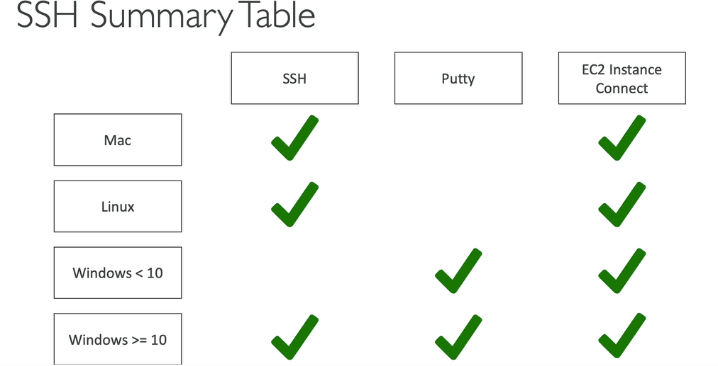

**What is Bootstrapping in AWS?**

Bootstrapping in AWS simply means to add commands or scripts to AWS EC2’s instance User Data section that can be executed when the instance starts(boot task).

Bootstrapping means launching commands when a machine starts/restart

**EC2 User Data**

EC2 user data is script which runs when EC2 start (boot tasks/ command)

It is possible to bootstrap our instances using an EC2 instance User data script.

That script is **only run once** at the instance **first start**

EC2 user data is used to automate boot tasks such as:

* Installing updates
* Installing software
* Downloading common files from the internet
* Anything you can think of

The EC2 User Data Script runs with the root user

**Note:**

When we restart our EC2 instance then it’s Public IP may change but Private IP will not change.

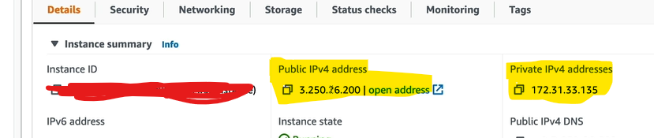

### EC2 Instance Types - Overview

* You can use different types of EC2 instances that are optimised for different use cases (<https://aws.amazon.com/ec2/instance-types/>)
  + [General Purpose](https://github.com/kananinirav/AWS-Certified-Cloud-Practitioner-Notes/blob/master/sections/ec2.md#general-purpose)
  + [Compute Optimized](https://github.com/kananinirav/AWS-Certified-Cloud-Practitioner-Notes/blob/master/sections/ec2.md#compute-optimized)
  + [Memory Optimized](https://github.com/kananinirav/AWS-Certified-Cloud-Practitioner-Notes/blob/master/sections/ec2.md#memory-optimized)
  + [Storage Optimized](https://github.com/kananinirav/AWS-Certified-Cloud-Practitioner-Notes/blob/master/sections/ec2.md#storage-optimized)
  + Accelerated Computing
* AWS has the following naming convention: m5.2xlarge
* m: instance class
* 5: generation (AWS improves them over time)
* 2xlarge: size within the instance class

#### **General Purpose**

The computation, memory, and networking resources in general-purpose instances are balanced. General Purpose Instances **can be used for gaming servers, small databases, personal projects, etc**

* Great for a diversity of workloads such as web servers or code repositories
* Balance between:
  + Compute
  + Memory
  + Networking

#### **Compute Optimized**

Compute-optimized instances are appropriate for applications that **require a lot of computation and need high-performance CPUs.**

* Great for compute-intensive tasks that require high performance processors:
  + **Batch processing workloads**
  + Media transcoding
  + High performance web servers
  + High performance computing (HPC)
  + **Scientific modelling & machine learning, data science application**
  + Dedicated gaming servers

#### **Memory Optimized**

Memory-optimized instances are geared for workloads that **need huge datasets/information/data to be processed in memory (RAM)**.

* Fast performance for workloads that process large data sets in memory
* Use cases:
  + High performance, relational/non-relational databases
  + Distributed web scale cache stores
  + In-memory databases optimized for BI (business intelligence)
  + Applications performing real-time processing of big unstructured data

#### **Storage Optimized**

Storage-optimized instances are made for workloads that demand **fast, sequential read and write access to huge datasets**. Best for - Distributed file systems, data warehousing applications, and high-frequency online transaction processing (OLTP) systems.

* Great for storage-intensive tasks that require high, sequential read and write access to large data sets on local storage
* Use cases:
  + **High frequency online transaction processing (OLTP) systems**
  + Relational & NoSQL databases
  + Cache for in-memory databases (for example, Redis)
  + **Data warehousing applications**
  + **Distributed file systems**

**Accelerated Computing Instances**

Co-processors are used in accelerated computing instances to execute specific operations more effectively than software running on CPUs.

Best for - **Scientific calculation, AI and ML modelling etc**

**Security Group**

Security Groups are the fundamental of network security (like firewall) in AWS

They **control how traffic is allowed into or out of our EC2 Instances or VPC(if created and attached to VPC)**

Security groups only contain allow rules

Security groups rules can reference by IP or by security group

It acts as virtual firewall for instances to control the inbound and outbound traffic.

**Security group Deeper Dive**

* Security groups are acting as a “firewall” on EC2 instances
* They regulate:
* Access to Ports
* Authorised IP ranges – IPv4 and IPv6
* Control of inbound network (from other to the instance, **by default blocked from all IP**)
* Control of outbound network (from the instance to other, **by default allow for all IP**)

**Security Groups Diagram**



**Good to know**

* One security group Can be attached to multiple instances
* One EC2 instance can hev multiple security group attached to it.
* Locked down to a region / VPC combination
* Does live “outside” the EC2 – if traffic is blocked the EC2 instance won’t see it
* It’s good to maintain one separate security group for SSH access
* If your application is not accessible (time out), then it’s a security group issue
* If your application gives a “connection refused“ error, then it’s an application error or it’s not launched
* **All inbound traffic is blocked by default**
* **All outbound traffic is authorized by default**

**Classic Ports to know**

* 22 = SSH (Secure Shell) - log into a Linux instance
* 21 = FTP (File Transfer Protocol) – upload files into a file share
* 22 = SFTP (Secure File Transfer Protocol) – upload files using SSH
* 80 = HTTP – access unsecured websites
* 443 = HTTPS – access secured websites
* 3389 = RDP (Remote Desktop Protocol) – log into a Windows instance

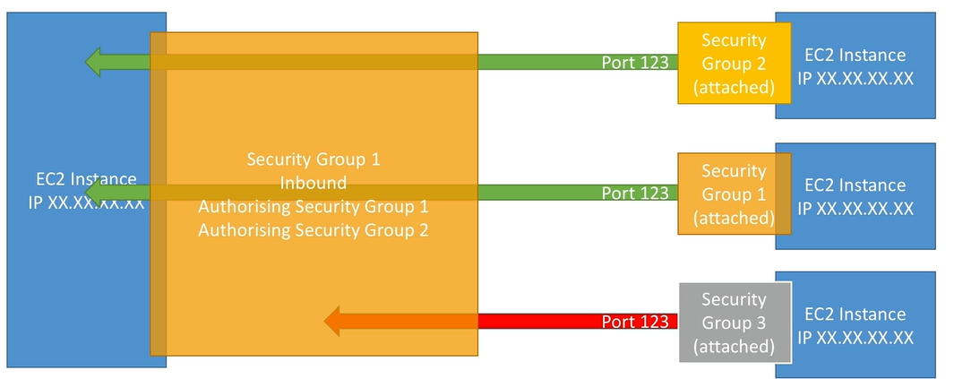

**AWS pricing options:**

* **On-demand**
* **Spot instances** (discounted short-term capacity if available **90% cheaper than On-demand**)
* **Savings Plans( 1 or 3 year)**

Commitment to a certain amount of usage for min. 1 year)

* + Compute Saving plan
  + Saving plan
* **Reserved Instances (1 or 3 year)**

Discounted reserved long-term capacity, 70% cheaper than on demand)

* + All upfront
  + Partial upfront
  + No upfront
* **Dedicated Hosts** (Physical server only for you, on-demand hourly or by reserved instances)
* **Capacity Reservation**: Reserve capacity in a specific AZ for any duration.



**Reserve Instances types**

|  | **Standard Reserved Instance** | **Convertible Reserved Instance** |
| --- | --- | --- |
| Modify Reserved Instances | Some attributes can be modified. For more information, see [Modify Reserved Instances](https://docs.aws.amazon.com/AWSEC2/latest/UserGuide/ri-modifying.html). | Some attributes can be modified. For more information, see [Modify Reserved Instances](https://docs.aws.amazon.com/AWSEC2/latest/UserGuide/ri-modifying.html). |
| Exchange Reserved Instances | **Can't be exchanged**. | **Can be exchanged during the term for another Convertible Reserved Instance with new attributes, including instance family, instance type, platform, scope, or tenancy. For more information**, see [Exchange Convertible Reserved Instances](https://docs.aws.amazon.com/AWSEC2/latest/UserGuide/ri-convertible-exchange.html). |
| Sell in the Reserved Instance Marketplace | Can be sold in the Reserved Instance Marketplace. | Can't be sold in the Reserved Instance Marketplace. |
| Buy in the Reserved Instance Marketplace | Can be bought in the Reserved Instance Marketplace. | Can't be bought in the Reserved Instance Marketplace. |

**EC2 On Demand**

* Pay for that you use
  + **Linux or Window -- Billing per second after first minute**
  + **All other operating system -- billing per hour**
* Has the highest cost but no upfront payment
* No long-term commitment
* Recommended for short-term and un-interrupted workloads, where you cannot predict the application behave

**EC2 Reserved Instances**

* Up to 72% (appx. may vary) discount compared to On-demand
* You reserve specific instance attributes (Instance type, region, tenancy, Os)
* Reservation period --- 1 year to 3 years (max discount)
* Payment options --- No upfront, Partial Upfront, All Upfront (max discount)
* Reserved instance scope -- Regional or Zonal
* Recommended for steady-state usage application (think database)
* We can buy and sell in the reserved instance marketplace
* Convertible Reserved Instance
  + can change the EC2 instance type, instance family, OD, scope, and tenancy
  + Up to 66% discount

**EC2 Saving Plan**

* Get a discount based on long-term usage ( upto 72% -- same as RIs)
* Commitment to a certain type of usage ( e.g $10/hour for 1 or 3 year)
* Usage beyond saving plans is billed at the On-Demand prise
* Locked to a specific instance family and AWS region
* Flexible across
  + Instance size
  + OS type
  + Tenancy (Host, dedicated, default)

**EC2 Dedicated Hosts**

* A physical server with EC2 instance capacity fully dedicated to your use
* Allows you address compliance requirements and use your existing server-bound software licenses (per-pocket, per-core, pe-r VM software licenses
* Purchasing options:
  + On-Demand -- Pay per second for active dedicated Hosts
  + Reserved -- for 1 or 3 year(No upfront, Partial upfront, All upfront)
* This is most expensive pricing option

**EC2 Spot Instance Request**

* Can get saving upto 90%
* Define max spot price and get the instance while current sport price < max
* The hourly spot price varies based on offer and capacity
* If the current spot price> your max price you can choose to stop or terminate your instance within a 2 minute graces period

**Spot Fleets**

* Spot Fleets == set of spot instance + On demand instance(optional)
* The Spot fleet will try to meet the target capacity with price constraints
* Define possible launch pools, so that the fleet can choose
* Spot Fleet stops launching instance when reaching capacity or max cost

**AWS charges for IPv4 addresses**

* Starting February 1st 2024, there is charge ($.0005) for all Public IPv4 created in your account
* For new accounts in AWS, we have free tier for EC2 service (750 hours of Public IPv4 per month for first 12 month)
* For all other services there is no free tier

**Payment Options for EC2 Reserved Instances**

We have below three payment options for reserved instance

* All Upfront
* Partial Upfront
* No Upfront

**All Upfront** – You **make a full payment at the start of the term of the Reserved Instance**, with no other costs or additional hourly charges incurred, regardless of hours used. **This payment option yields the highest discounts**.

**Partial Upfront** – You pay a portion of the cost up front, which will require capital of 30-50% of the total Reserved Instance value. AWS will bill the remaining hours in the term at a discounted hourly rate, regardless of whether the Reserved Instance is being used or not.

**No Upfront** – Just like it sounds, **no upfront capital is required** when you choose this option. AWS documentation defines this payment as “a discounted hourly rate for every hour within the term, regardless of whether the Reserved Instance is being used.” By choosing No Upfront Reserved Instances, you have a contractual obligation to pay monthly for the entire term of the reservation.

**########################**

**# PRIVATE vs PUBLIC IP #**

**########################**

**Private vs Public IP**

For the AWS Arch certification course, we need to know about the IPv4 but AWS supports IPv6 also.

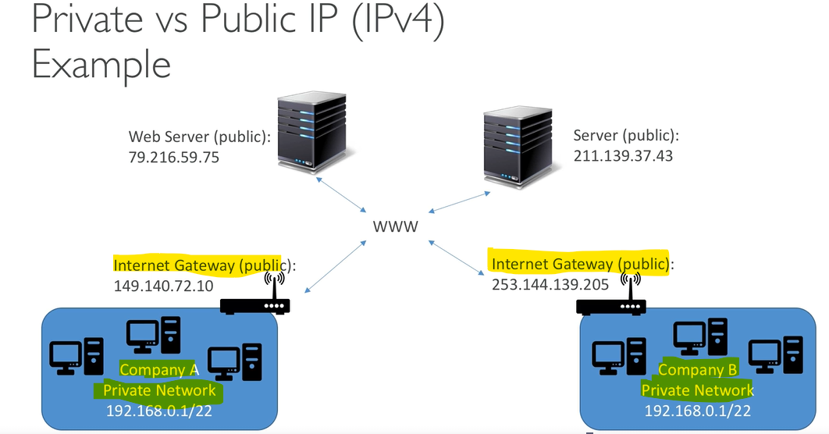

**Note:**

*From above diagram we can see that resource of private IP comminates using Internet Gateway and NACL.*

**Public IP**

* Publick IP means the machine can be identified on the internet(www)
* Must be unique across the whole web(not two machine can have the same public IP)
* Can be geo-located easily

**Private IP**

* Private IP means the machine can only be identified on private network only
* The IP must be unique across the private network
* But two different private network(two companies) can be the same IP (within each organization, in private network)
* Machine connect for www using a NAT and Internet Gateway

**Placement groups**

Placement groups are a mechanism used in Amazon Elastic Compute Cloud (EC2) for controlling the placement of instances.

1. **Cluster**: Clusters instances into a low-latency group in a single availability zone.

* Great bandwidth (10 Gbps)

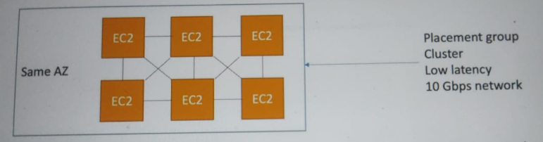

1. **Spread**: Spreads instances on different hardware and AZ (max 7 instance group per AZ) ---Critical application.

**Advantage:**

* Can span across Availability Zones (AZ)
* Reduced risk is simultaneous failure
* EC2 instances are on different physical server

**Disadvantage**:

* Limits to 7 instances per AZ

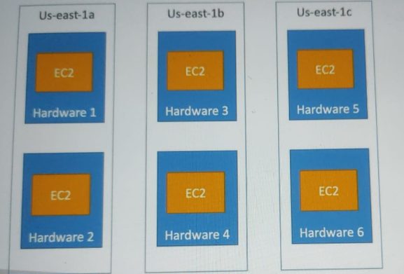

1. **Partition**: Spreads instances across many different partition (which rely on different set of ranks) within in AZ, Scales to 100s of EC2 instance per group (Hadoop, Casandra, Kafka).

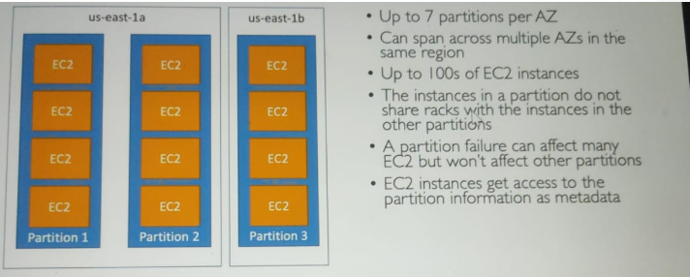

**Elastic Network Interfaces (ENIs)**

* Elastic Network Interfaces (ENIs) are logical networking components within a Virtual Private Cloud (VPC) in AWS. They function as virtual network cards, providing network connectivity for EC2 instances and other AWS services.
* For EC2 AWS itself provides the ENI for each EC2 but we can also create additional ENI and attached to a EC2 ( as secondary ENI).
* **ENI is bounded to availability zone.**

**Attributes of ENI**

* Each ENI must have a primary private IPv4 address from the VPC’s IPv4 address range.
* ENIs **can have one or more secondary private IPv4 addresses**. This is useful for applications requiring multiple IP addresses on a single instance.
* You can associate one or more Elastic IP addresses (IPv4) with a primary or secondary private IP address on the ENI.
* ENIs **can also have IPv6 addresses if your VPC supports IPv6**.
* Each **ENI has a unique MAC address,** which is crucial for network communication.
* **ENIs can have one or more security groups attached. Security groups act as virtual firewalls to control inbound and outbound traffic to the ENI**.
* ENIs support resource-based permissions policies. This means you can control who can attach or detach the ENI from instances.

**EC2 Hibernate**

Before EC2 Hibernate let's take catch on EC2 Stop, start and Boot:-

* **Stop**: The data on disk (EBS) is kept intact till the next start.
* **Terminate**: Ay EBS volume(root) also set-up to be destroyed is lost.
* **Boot**: The OS boots and the EC2 user data script is ran (first start).

OS boot up (Following starts)

Then application starts, caches get warmed up.

**EC2 Hibernate (something like sleep moe)**

* **The in-memory (RAM) state is preserved**
* The instance boot is much faster
* Under the hood: the RAM is written to a file in the root EBS
* The root EBS must be encrypted

|  |  |
| --- | --- |
| **Use Cases:**  Long-running process  Saving the RAM state  Services that take time to initialize   * **RAM size must be less than 150GB.** * **Root volume** -- **Must be EBS, encrypted, not instance store and large** * **Available for -- On-Demand, Reserved and Spot instance** * **Instance can be hibernated for more than 60 days** |  |

**##########################################################################**

**# EC2 Instance Storage #**

**##########################################################################**

**Elastic Block Storage (EBS)**

* It is a **network drive** ( i.e not a physical drive)
  + It is used the network to communicate the instance which means there might be a bit of latency)
  + It can be detached from an EC2 instance and attached to another one quickly
* It's is **locked to an availability zone** (AZ)
  + An EBS volume in us-east-1a cannot be attached to us-each-1b
  + To move a volume across, you first need to take snapshot of it.
* Have a **provisioned capacity (sizes in GBs and IOPS)**
* You **get billed for all the provisioned capacity(not the used space from provisioned)**.
* You can increase the capacity of the drive over time

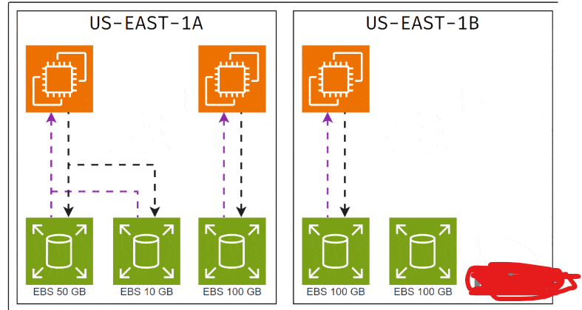

Elastic Block Storage (EBS) is a block type durable and persistent storage that can be attached to EC2-instances for additional storage.

* By default, space assigned to EC2 instance are root volume, which gets deleted (by default, can be changed to not delete using console) on instance termination.
* EBS volumes are specific to availability zones and can only be attached to instances within the same availability zone.
* EBS Volumes are independent of the EC2 they are attached to. The data in an EBS volume will remain unchanged even if the instance is rebooted or terminated.
* They are bound to a specific availability zone
* Free tier: 30 GB of free EBS storage of type General Purpose (SSD) or Magnetic per month

**Features of EBS:**

**Scalability:** EBS volume sizes and features can be scaled as per the needs of the system. This can be done in two ways:

* Take a snapshot of the volume and create a new volume using the Snapshot with new updated features.
* Updating the existing EBS volume from the console.

**Backup:** Users can create snapshots of EBS volumes that act as backups.

* Snapshot can be created manually at any point in time or can be scheduled.
* Snapshots are stored on AWS S3 and are charged according to the S3 storage charges.
* Snapshots are incremental in nature means billed for changes block each time snapshot taken.
* New volumes across regions can be created from snapshots.

**Encryption:** Encryption can be a basic requirement when it comes to storage. This can be due to the government of regulatory compliance. **EBS offers an AWS managed encryption feature.**

Users can enable encryption when creating EBS volumes by clicking on a checkbox.

* Encryption Keys are managed by the Key Management Service (KMS) provided by AWS.
* Encrypted volumes can only be attached to selected instance types.
* Encryption uses the AES-256 algorithm.
* Snapshots from encrypted volumes are encrypted and similarly, volumes created from snapshots are encrypted.

**Charges:** Unlike AWS S3, where you are charged for the storage you consume, AWS charges users for the storage you hold. For example if you use 1 GB storage in a 5 GB volume, you’d still be charged for a 5 GB EBS volume.

* EBS charges vary from region to region.

**EBS – Delete on Termination attribute**

* Controls the EBS behaviour when an EC2 instance terminates
  + By default, the root EBS volume is deleted (attribute enabled)
  + By default, any other attached EBS volume is not deleted (attribute disabled)
* This can be controlled by the AWS console / AWS CLI
* Use case: preserve root volume when instance is terminated

**EBS Snapshots**

* Make a backup (snapshot) of your EBS volume at a point in time
* Not necessary to detach volume to do snapshot, but recommended
* **We can copy snapshots(of created/taken snapshot) across any AZ or any Region**

**EBS Snapshots Features**

* EBS Snapshot Archive
  + Move a Snapshot to an ”archive tier” that is 75% cheaper
  + Takes within 24 to 72 hours for restoring the archive
* Recycle Bin for EBS Snapshots
  + Setup rules to retain deleted snapshots so you can recover them after an accidental deletion
  + Specify retention (from 1 day to 1 year)
* EBS snapshots are incremental

**AMI (Amazon Machine Image) Overview**

* AMI are customization of EC2 instance, it’s not global service/entity
  + You add your own software, configuration, operating system, monitoring etc
  + Faster boot/configuration time because all your software is pre-packaged
* AMI are built for specific region(can be copied across regions)
* You can launch EC2 from:
  + A Public AMI: AWS provided
  + Your own AMI: you make and maintain them yourself
  + An AWS Marketplace AMI: am AMI someone else made(and potentially sells)

**AWS AMI Process (from and EC2 instance)**

* Start and EC2 instance and customize it.
* Stop the instance (for data integrity)
* Build an AMI - This will also create EBS snapshots
* Launch instance from other AMIs

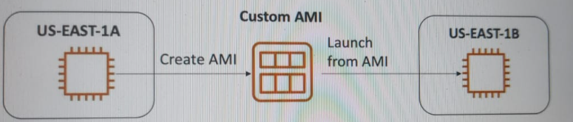

**EC2 Instance Store/Storage**

EC2 Instance store is used as a temporary data storage for EC2 but need high performance.

* EBS volumes are network drives with good but limited performance.
* If you need a high-performance hard disk then use EC2 instance store.
* EC2 instance store lose their storage if they are stopped(ephemeral)
* Good for buffer/ cache/ scratch data / temporary content(for long term storage – EBS or others )
* Risk of data loss if hardware fails.
* It is physically attached to host computer and block level storage

**EFS - Elastic File System**

* It is managed NFS (network file system) that can be mounted on 100s of EC2
* EFS works with Linux EC2 instance in **multi-AZ (sample paper) and Hybrid Service.**
* Highly available, scalable, expensive, pay per use, no capacity planning.
* EC2 from another **AZ, another Region** can access data of EFS.
* Pay for each read-write operation in EFS

|  |  |
| --- | --- |
|  | * **Use cases:**   Content management.  web serving, data sharing, Wordpress   * Uses NFSv4.1 protocol * **Uses security group to control access to EFS** * Compatible with Linus based AMI (not Windows) * Encryption at rest using KMS |

**EBS vs EFS**



**EFS Infrequent Access-IA**

* It's a storage call that is cost optimized for files not accessed every day
* Upto 92% lower cost compare to EFS standard
* EFS will automatically move your files to EFS-IA based on the last time they were accessed

**Note:**

*EFS supports high availability because it has multi-AZ deployments*. – Sample paper

**EBS Types**

On hight level we can classify the EBS volumes in two types-

* **SSD Types:**
  + gp2/gp3
  + io2 Block Express
  + io1
* **HDD Types:**
  + st1
  + st2
* **SSD-backed volumes** are optimized for transactional workloads involving **frequent read/write operations with small I/O size, where the dominant performance attribute is IOPS.** SSD-backed volume types include General Purpose SSD and Provisioned IOPS SSD.
* **HDD-backed volumes are optimized for large streaming workloads** where the dominant performance attribute is throughput. HDD volume types include Throughput Optimized HDD and Cold HDD.

**Provisioned IOPS SSD use cases:**

* Critical business application with sustained IOPS performance
* Application that needs more than 16000 IOPS and **can works as root/boot volume**
* **Great for Database workloads (sensitive to storage performance and consistency)**
* Supports **EBS Multi-attach**

**Provisioned IOPS HDD use cases:**

* Can not be boot volume
* Throughputs optimized ( Big data, Data warehouse, log processing)
* Cold HDD: for data that is accessed less frequently

**EBS SSD VOLUMES**

|  |  |
| --- | --- |
| [**Amazon EBS General Purpose SSD volumes**](https://docs.aws.amazon.com/ebs/latest/userguide/general-purpose.html) | [**Amazon EBS Provisioned IOPS SSD volumes**](https://docs.aws.amazon.com/ebs/latest/userguide/provisioned-iops.html) |

|  |  |  |  |  |
| --- | --- | --- | --- | --- |
| **Volume type** | gp3 | gp2 | io2 Block Express 3 | io1 |
| **Durability** | 99.8% - 99.9% durability (0.1% - 0.2% annual failure rate) | | 99.999% durability (0.001% annual failure rate) | 99.8% - 99.9% durability (0.1% - 0.2% annual failure rate) |
| **Use cases** | * Transactional workloads * Virtual desktops * Medium-sized, single-instance databases * Low-latency interactive applications * Boot volumes * Development and test environments | | Workloads that require:   * Sub-millisecond latency * Sustained IOPS performance * More than 64,000 IOPS or 1,000 MiB/s of throughput | * Workloads that require sustained IOPS performance or more than 16,000 IOPS * I/O-intensive database workloads |
| **Volume size** | 1 GiB - 16 TiB | | 4 GiB - 64 TiB 4 | 4 GiB - 16 TiB |
| **Max IOPS** | 16,000 (64 KiB I/O 6) | 16,000 (16 KiB I/O 6) | 256,000 5 (16 KiB I/O 6) | 64,000 (16 KiB I/O 6) |
| **Max throughput** | 1,000 MiB/s | 250 MiB/s 1 | 4,000 MiB/s | 1,000 MiB/s 2 |
| **Amazon EBS Multi-attach** | Not supported | | Supported | |
| **NVMe reservations** | Not supported | | Supported | Not supported |
| **Boot volume** | Supported | | | |

**EBS HDD VOLUMES**

|  |  |
| --- | --- |
| [**Throughput Optimized HDD volumes**](https://docs.aws.amazon.com/ebs/latest/userguide/hdd-vols.html#EBSVolumeTypes_st1) | [**Cold HDD volumes**](https://docs.aws.amazon.com/ebs/latest/userguide/hdd-vols.html#EBSVolumeTypes_sc1) |

|  |  |  |
| --- | --- | --- |
| **Volume type** | st1 | sc1 |
| **Durability** | 99.8% - 99.9% durability (0.1% - 0.2% annual failure rate) | |
| **Use cases** | * Big data * Data warehouses * Log processing | * Throughput-oriented storage for data that is infrequently accessed * Scenarios where the lowest storage cost is important |
| **Volume size** | 125 GiB - 16 TiB | |
| **Max IOPS per volume** (1 MiB I/O) | 500 | 250 |
| **Max throughput per volume** | 500 MiB/s | 250 MiB/s |
| **Amazon EBS Multi-attach** | Not supported | |
| **Boot volume** | Not supported | |

**Multi-attach EBS**

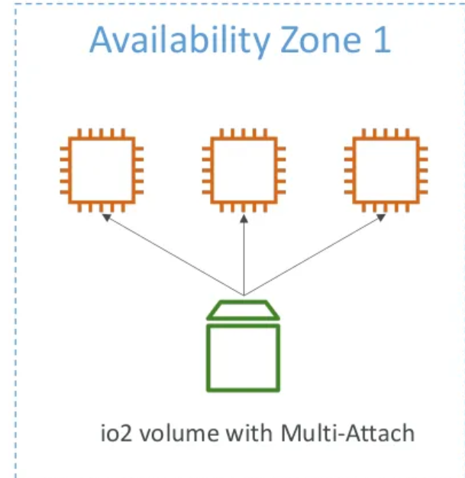

* **Attach the same volume to multiple EC2 in same AZ**.
* Each instance has full read-write permission to high performance volume.
* **Upto 16 instance at a time**
* Must use a file system that is cluster-ware.
* **Use case**:
  + Achieve higher application availability in clustered Linux application.
  + Application must manage concurrent write operation.

**EBS Encryption**

* While create the EBS, we have option to enable the encryption in console.

**Encryption: encrypt an unencrypted volume**

* Create and EBS snapshot of the volume
* Encrypt the EBS snapshot (using copy)
* Create new EBS volume from the snapshot (the volume will also be encrypted)
* Now you can attach the encrypted volume to the original instance

**######################################################################################**

**# Elastic Load Balancing & Auto Scaling Groups #**

**######################################################################################**

**Scalability & High Availability**

* Scalability means that an application / system can handle greater loads by adapting.
  + There are two kinds of scalability:
    - Vertical Scalability
    - Horizontal Scalability (= elasticity)
* Scalability is linked but different to High Availability

**Vertical Scalability**

* Vertical Scalability means increasing the size/computing power of the same instance/resource
* For example, your application runs on a t2.micro
* Scaling that application vertically means running it on a t2.large
* Vertical scalability is very common for non-distributed systems, such as a database.
* There are usually a limit to how much you can vertically scale (hardware limit)

**Horizontal Scalability**

* Horizontal Scalability means increasing the number of instances / systems for your application
* Horizontal scaling implies distributed systems.
* This is very common for web applications / modern applications
* It’s easy to horizontally scale thanks the cloud offerings such as Amazon EC2

**High Availability**

* High Availability usually goes hand in hand with horizontal scaling
* High availability means running your application / system in at least 2 Availability Zones
* The goal of high availability is to survive a data centre loss (disaster)

| **Scalability** | **Elasticity** | **Agility** |
| --- | --- | --- |
| Ability of system to grow and shrink the resource to meet the demand very quickly | Ability to acquire the resource and discard rapidly when needed. | (not related to scalability - distractor) means IT resources are only a click away, which means that you reduce the time to make those resources available to your developers from weeks to just minutes. |

**Agility --(sample paper)**

It refers the ability to develop, test and launch software application that drive business growth in another words ***ability to quickly innovate, experiment and iterate quickly***.

**Reliability**

Ability of workload to perform it’s intended function correctly and consistently when it’s expected. This includes ability of workload to operate and test though it’s lifecycle.

**Resiliency**

Ability of workload to recover from infrastructure disruptions, dynamically acquiring computing resource to meet demand and mitigate disruption.

**Availability** --- Deploying resource/services/application on different AZ of same region

**Disaster recovery** --- Deploying resource/services/application on diff AZ of different region or in diff region.

**What is load balancing?**

Load balancers are servers that forward internet traffic to multiple servers (EC2 Instances) to handle it.

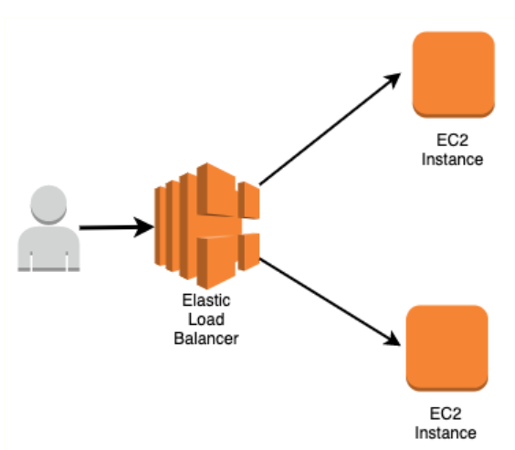

**Why use a load balancer?**

* Spread load across multiple downstream instances
* Expose a single point of access (DNS) to your application
* Seamlessly handle failures of downstream instances
* Does regular health checks to your instances
* Provide SSL termination (HTTPS) for your websites
* High availability across zones

**Why use an Elastic Load Balancer?**

* An ELB (Elastic Load Balancer) is a managed load balancer
  + AWS guarantees that it will be working
  + AWS takes care of upgrades, maintenance, high availability, fault tolerance
  + AWS provides only a few configurations knobs
* It costs less to setup your own load balancer but it will be a lot more effort on your end (maintenance, integrations)
* 4 kinds of load balancers offered by AWS: ---- **Sample Paper**
  + **Application Load Balancer** (HTTP / HTTPS , gRPConly, HTTP Routing, Static DNS) – Layer 7
  + **Network Load Balancer** (ultra-high performance, allows for TCP, TLS, UDP) – Layer 4
  + **Classic Load Balancer** (slowly retiring) – Layer 4 & 7
  + **Gateway load balancer** – layer 3
* Integrated with many AWS offering/services
  + **EC2, EC2 Auto scaling group, Amazon ECS**
  + **AWS Certified manager (ACM), Cloud Watch**
  + **Route 53, AWS WAF, AWS Global accelerator)**

**Note:**

* All these of load balancers (ELBs) that all feature the high availability, automatic scaling, and robust security necessary to make your applications fault-tolerant.
* We should link the Load balancer to EC2 like security group from where EC2 will communicate

**Health Checks**

* Health Checks are crucial for Load Balancer.
* They enabled the load balancer to know if instance is working good.
* The health check is done on a port and a route.
* If the response is not 200(OK), then load balancer considers unhealthy
* Health checks are performed for HTTPS, HTTPS, TCP protocols

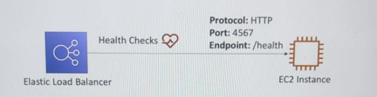

**Application Load Balancer (v2).**

* Application load balancer is Layer 7(HTTP).
* Load balancing to multiple HTTP application across machines (grouped, called target groups).
* Support for HTTP/2 and **WebSocket**.
* Support **redirects** (from HTTP to HTTPS for example)
* **Routing tables** for difference target groups
  + Routing **based on hostname** in URL
  + Routing **based on Query String**, header
  + Routing **based on path in URL**
* ALB are **great fit for micro services and container-based application (Docker)**
* Has a port mapping feature to **redirect to a dynamic port in ECS**
* In comparison, we would need multiple Classic load Balancer per application
* Provides only static DNS.

**Network Load Balancer**

* Network Load Balancer (**Layer 4**) allow to:
  + Forward TCP & UDP traffic to your instances
  + Handle **millions of requests per seconds**
  + **Ultra-low latency**
* **NLB has one static IP per AZ, and supports assigning Elastic IP**
* **Health checks are performed by NLB also**
* **Provides Static IP and Static DNS both.**

**GATEWAY LOAD BALANCER**

* Used to deploy, scale and manage a fleet of third party network virtual appliances in AWS
* Example: Want to first route all incoming traffic to Firewalls, Intrusion Detection and prevention system etc before going to application/ECC2/target

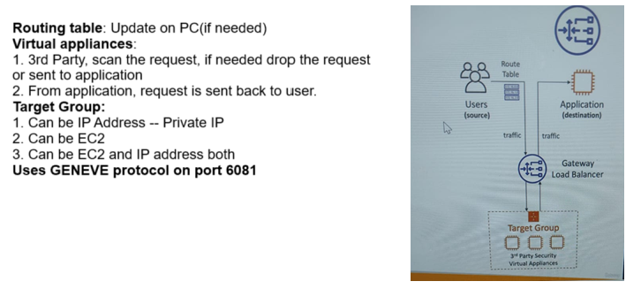

* Target group can consist of :- EC2 instance, IP address , Lambda

**Sticky Session ( Session affinity )**

* It is possible to implement stickiness to users so that the **same client is always redirected to the same instances behind the load balancer**
* Works for classic load balancer, application, and network load balancer
* Cookie is used for stickiness that has expiration date that we can control.
* **Cons**: **may create imbalance in the application**

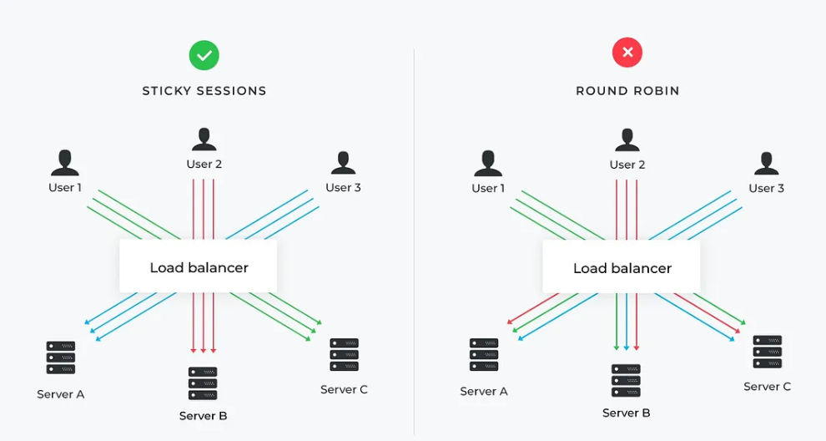

**Cross-Zone load balancing**

Using cross-zone load balancing, **the load is spread across all available *instances* in the Region**, reducing the impact of misbehaving clients.

**Application load balancer**

* Cross-zone load balancing is **enabled** at target group level by default (can be disabled)
* **No charge** for inter AZ data.

**Network load balancer**

* Cross-zone is **disabled** by default.
* If cross-zone enabled for Network load balancer then **will be charged**.

**Classic load balancer**

* **Disabled** by default, can be enabled
* **No charge** for inter AZ data if enabled

|  |  |
| --- | --- |
| **Cross-Zone load balancing**    **Note:**  We can see incoming request is **evenly distributed** (10%, because we have total 10 instance) on each instance though they are in different AZ | **Without Cross-Zone load balancing**    **Note:**  We can see incoming request is **not evenly distributed** 50% in each AZ then then evenly distributed among each instance of same AZ |

**## Connection Draining ##**

* It has two different name in different LB.

1. For CLB --- Connection Draining
2. For ALB and NLB – Deregistration Delay

* **Time to complete "in-flight requests" while the instance is de-registering or unhealthy.**
* **Stops sending new requests to the EC2 instance which is deregistering.**
* Time can be setup between 1 sec to 3600 sec(default 300 sec)
* Can be disabled (set value to 0)
* Set to a low value if your requests are short.

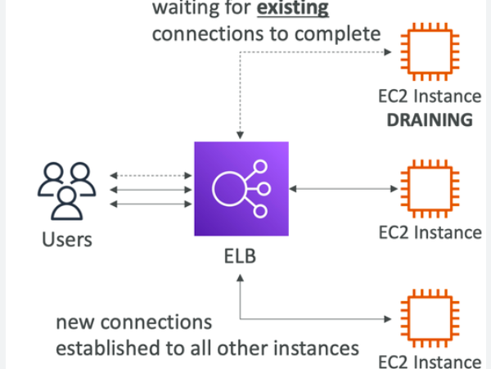

**What’s an Auto Scaling Group**

AWS Auto-Scaling is a mechanism that automatically permits you to increase or decrease your resources to meet demand based on custom-defined metrics and thresholds.

An Auto Scaling group contains a collection of EC2 instances that are treated as a logical grouping for the purposes of automatic scaling and management.

It make sures that we have always right amount of resources to handle incoming traffic.

* In real-life, the load on your websites and application can change
* In the cloud, you can create and get rid of servers very quickly
* The goal of an Auto Scaling Group (ASG) is to:
  + Scale out (add EC2 instances) to match an increased load
  + Scale in (remove EC2 instances) to match a decreased load
  + Ensure we have a minimum and a maximum number of machines running
  + Automatically register new instances to a load balancer
  + Replace unhealthy instances
* Cost Savings: only run at an optimal capacity (principle of the cloud)

**Note:**

* *Auto Scaling is free but you pay for underlying services(e.g EC2) like CloudFormation – Sample Paper*

**Auto Scaling Groups Scaling Strategies**

* **Manual Scaling:** Update the size of an ASG manually
* **Dynamic Scaling:** Respond to changing demand
  + Simple / Step Scaling
    - When a CloudWatch alarm is triggered (example CPU > 70%), then add 2 units
    - When a CloudWatch alarm is triggered (example CPU < 30%), then remove 1
  + Target Tracking Scaling
    - Example: I want the average ASG CPU to stay at around 40%
  + Scheduled Scaling
    - Anticipate a scaling based on known usage patterns
    - Example: increase the min. capacity to 10 at 5 pm on Fridays
  + Uses Machine Learning to predict future traffic ahead of time
  + Automatically provisions the right number of EC2 instances in advance
* Useful when your load has predictable time - based patterns
* **Predictive Scaling**
  + Uses Machine Learning to predict future traffic ahead of time
  + Automatically provisions the right number of EC2 instances in advance

**########################################################################################### DataBase and Analytics #####**

**#######################################################################################**

On high level we can classify the database in two types—

1. SQL Database or Relational Database
2. NoSQL database or Non-Relational Database

**SQL Database:**

It is used when we want to store data in tabular form.

In SQL database **data have schema, datatype, length which add a constraint/limitation**.

In almost all situations **SQL databases are vertically scalable** other hand, NoSQL databases are horizontally scalable.

It is best choice when working with related data.

Some popular SQL databases are: -

* MySQL
* MariaDB
* Oracle
* Microsoft SQL server
* Aurora ( AWS proprietary )

**NoSQL database**

A NoSQL database has a dynamic schema (means no schema, data type and length) for unstructured data.

Data can be stored in document, JSON or key-value format.

NoSQL database **are horizontally scalable**.

Best choice when the **dealing with huge data and quick availability**.

**Advantages of AWS RDS:**

In AWS we have below advantage of RDS over EC2

* RDS is managed/fully manages serviced that means-
  + Automated provisioning, OS patching.
  + Continuous backup and restore to specific timestamp.
  + Monitoring dashboard
  + Read replicas for improved read performance
  + Multi AZ setup for DR(disaster recovery)
  + maintenance windows for upgrade
  + Scaling capability
  + Storage backed by EBS

**RDS Storage Auto Scaling**

* Helps to increase storage of RDS dynamically
* When RDS detects it's running out of space, it scales automatically.
* Avoid manually scaling your database storage.
* You have to set Maximum Storage Threshold (max limit for DB storage)
* Automatically modify storage when:
  + Free storage is less than 10% of allocated space.
  + Low-storage lasts at least 5 minutes
  + 6 hours have passed since last modification
* Useful for, application with unpredictable workload
* Storage auto scaling supports all RDS database engines.

**Drawback:**

We **can’t SSH into our instance**

**SQL vs NoSQL database**

| **SQL** | **NoSQL** |
| --- | --- |
| RELATIONAL DATABASE MANAGEMENT SYSTEM (RDBMS) | Non-relational or distributed database system. |
| These databases have fixed or static or predefined schema | They have a dynamic schema |
| These databases are not suited for hierarchical data storage. | These databases are best suited for hierarchical data storage. |
| These databases are best suited for complex queries | These databases are not so good for complex queries |
| Vertically Scalable | Horizontally scalable |
| Follows ACID property | Follows CAP(consistency, availability, partition tolerance) |
| **Examples:** [MySQL](https://www.geeksforgeeks.org/mysql-common-mysql-queries/), [PostgreSQL](https://www.geeksforgeeks.org/what-is-postgresql-introduction/), Oracle, MS-SQL Server, etc | **Examples:** [MongoDB](https://www.geeksforgeeks.org/mongodb-tutorial/), HBase, Neo4j, Cassandra, etc |

**### RDS Deployment ####**

**Read replica**

Read replica (**same or different region/AZ replication**) is the copy of your DB from where we can read the data.

Read replica may be setup in another region also using CRR policy, leading to disaster recovery also.

This is **used to reduce the load on your DB.** **We can create upto 15 read replica**.

While doing the **write operation data is always written into main DB**.

**Read replicas are available for Amazon RDS** ( MySQL, MariaDB, PostgreSQL, Oracle, SQL, Amazon Aurora )

|  |  |
| --- | --- |
|  | No cost if read replica is created within one region/AZ.  It is used to mainly **improve scalability.** |

* The main purpose of Read replica is scalability.
* Replication is ASYNC so read operation is consistent.
* **Application must update connection string to leverage read replica**

**Multi-AZ**

Multi-AZ is mainly used to be fail safe. (**high availability** and failover for any worst case)

In this case main database is for read/write. **Read/write happens in failover DB in case of failover situation**.

* One DNS name leads to auto failover in case of main RDS failure.
* **No down time is needed to deploy from single AZ RDS to multi-AZ RDS**, can be done on fly with no downtime ( just click on modify and change to multi AZ)

|  |  |
| --- | --- |
|  | When we change single AZ RDS to multi AZ, internally then :-   * it takes snapshot of main RDS. * Using backup another RDS is create. * **SYNC** is done between both RDS. |

**Multi-Region**

Disaster recovery in case of region issue.

Local performance for global issue.

Involve replication cost



**Read Replica vs Multi-AZ**

Of course, Rakesh! Here's a clear and structured table comparing **Read Replicas** and **Multi-AZ deployments** in AWS RDS:

| **🔍 Feature** | **🟣 Read Replica** | **🟢 Multi-AZ Deployment** |
| --- | --- | --- |
| **Purpose** | Scale **read-heavy** workloads | Provide **high availability** & failover |
| **Replication** | **Asynchronous** | **Synchronous** |
| **Data Consistency** | **Eventual consistency** | **Strong consistency** |
| **Accessibility** | **Readable & quarriable** | **Standby is inaccessible until failover** |
| **Failover Behaviour** | Manual promotion required | Automatic failover with minimal downtime |
| **Backups & Maintenance** | No automatic backups unless promoted | Backups from standby; minimal performance hit |
| **Typical Use Cases** | Analytics, reporting, read scaling | Disaster recovery, production-grade resilience |

**RDS Custom**

* The idea behind RDS Custom is that it *allows customers to do their customization on RDS or Instance hosting RDS.*
* RDS customs is *only for MYSQL and Oracle DB.*
* Customs:
  + Configure setting
  + Install patches
  + Enable native features.
* Access the underlying EC2 instance using SSH or SSM Session Manager
* Deactivate Automation mode before performing customization.

|  |  |  |
| --- | --- | --- |
| **Multi-AZ deployments** | **Multi-Region deployments** | **Read replicas** |
| Main purpose is high availability | Main purpose is disaster recovery and local performance | Main purpose is scalability |
| Non-Aurora: synchronous replication; Aurora: synchronous replication | Asynchronous replication | Asynchronous replication |
| Non-Aurora: only the primary instance is active; Aurora: all instances are active | All regions are accessible and can be used for reads | All read replicas are accessible and can be used for read scaling |
| Non-Aurora: automated backups are taken from standby; Aurora: automated backups are taken from shared storage layer | Automated backups can be taken in each region | No backups configured by default |
| Always span at least two Availability Zones within a single region | Each region can have a Multi-AZ deployment | Can be within an Availability Zone, Cross-AZ, or Cross-Region |
| Non-Aurora: database engine version upgrades happen on primary; Aurora: all instances are updated together | Non-Aurora: database engine version upgrade is independent in each region; Aurora: all instances are updated together | Non-Aurora: database engine version upgrade is independent from source instance; Aurora: all instances are updated together |
| Automatic failover to standby (non-Aurora) or read replica (Aurora) when a problem is detected | Aurora allows promotion of a secondary region to be the primary | Can be manually promoted to a standalone database instance (non-Aurora) or to be the primary instance (Aurora) |

**RDS vs RDS Customs:**

* RDS: entire DB and OS to be manages by AWS
* RDS Custom: full admin access to the underlying OR and the DB

**Amazon Aurora**

* It is **proprietary of AWS and Distributed DB**
* PostgreSQL and MYSQL are both supported as AWS Aurora
* Aurora is AWS cloud optimized and claims *5X performance improvement over MYSQL on RDX and 3X performance of Postgres on RDX.*
* Aurora storage automatically grows in increments of 10GB, up to 128 TB
* Aurora is more cost efficient (20% cheaper than other RDS)
* Can have *up to 15 read replica and replication is faster than MySQL.*
* *Failover is instantaneous, it’s high available native*.
* *Aurora Global DB can have replica upto 5 different region.*

**Aurora High Availability and Read Scaling**

* **6 copies of your data across 3 AZ(2 copies each AZ).**
* 4 copies out of 6 needed for writes.
* 3 copies out of 6 needed for reads.
* DB is **continuously backed by S3.**
* Self-healing with peer-to-peer replication.
* Storage is stripped across 100s of volumes.
* One Aurora instances takes write(master).
* Automated failover ofr master in less than 30 second.
* We **can setup auto scaling in Auroa and read replica** (at reader endpoints not writer endpoint)
* **Support backtracking (switching back to to given time )**

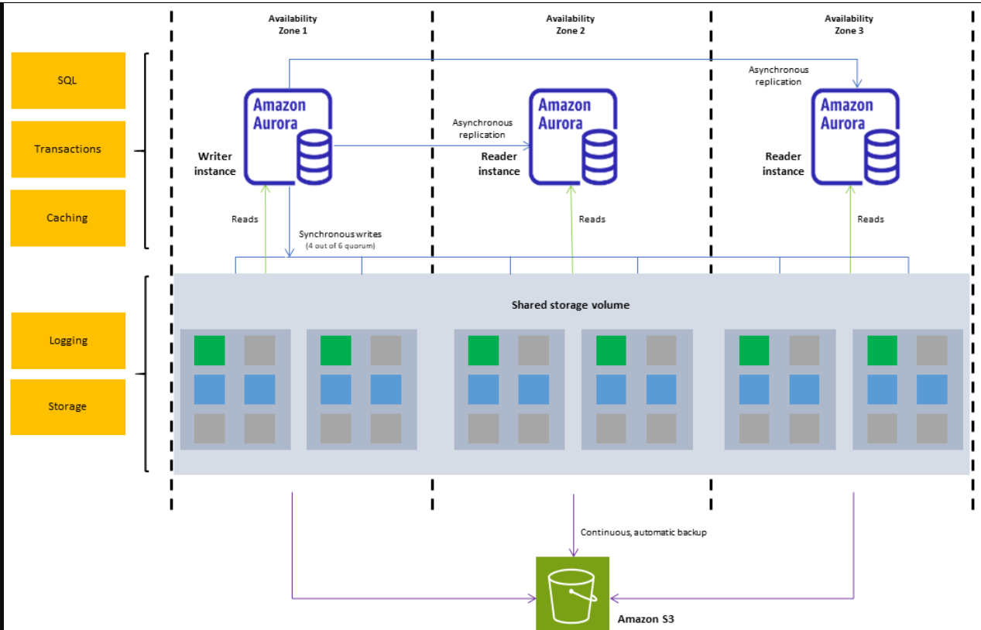

**Aurora Replica Auto Scaling**

Let say we have our Aurora RDS and it’s getting many requests, to handle more request we can increase replica by auto scaling

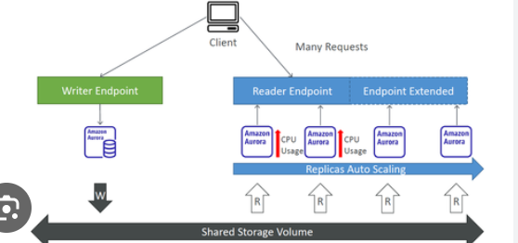

**Custom endpoint**

Let say some times we are going to **run analytical query which take more CPU** so

We can define a set **of instances as custom endpoints in Arora for few instances which would have large CPU capacity**.

**Aurora backups:**

* **Automated**
  + 1 to 35 days ( cannot be disabled)
  + Point in time recovery in that frame
* **Manual DB snapshot**
* Manually triggered by the user
* Retention of backup for as long as you want.

**RDS Backup**

* **Automated backup:**
  + Daily full backup of DB(during backup window)
  + Transaction logs are backed up by RDS every 5 minutes
  + Ability to restore to any point of time (from older to 5 minutes afo)
  + 1 to 35 days of retention period, set 0 to disable automated backups.
* **Manual backup:**
  + Manually triggered by user
  + Retention as long as you want

**RDS and Auror security**

* **At-rest encryption**
  + DB master and replicas encryption using AWS KMS -- must be defined as launch time
  + If master is not encrypted, the read replicas cannot be encrypted
  + To encrypt an un-encrypted DB, go through a DB snapshot and restore as ecrypted.
* **In Flight encryption**: TLS-ready by default, use the AWS TLS root certificates client side
* **IAM authentication:** IAM roles to connect to your DB(instead of username/password).
* **Security group:** Control network access to your RDS/Aurora DB.
* **No SSH available** except RDS Customs.
* **Audit logs** can be enabled and sent to CloudWatch logs for longer retention.

**RDS Proxy**

Consider a scenario where too many instances/request are coming to RDS that will lead to creating too many connection and RAM in creating/closing the connection. To avoid this we can proxy-

***Amazon RDS Proxy creates a pool of DB connections & shares them with the applications' different requests****.*

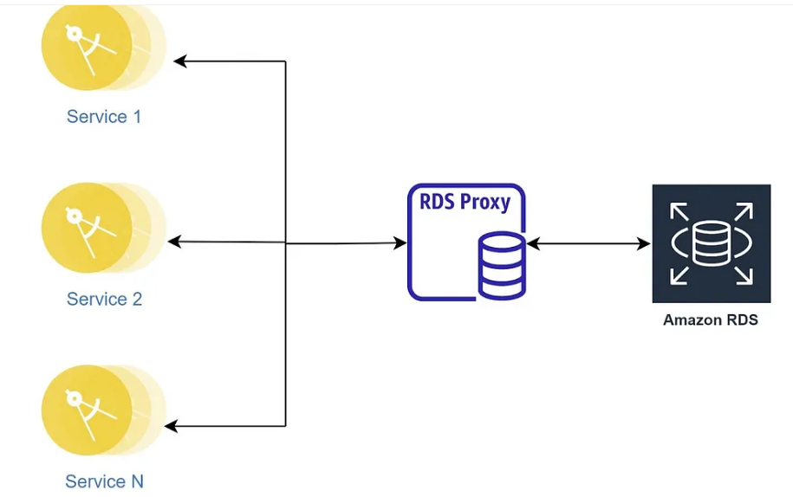

* AWS RDS is **fully AWS managed.**
* ***Allows apps to pool and share DB connections established with the DB***.
* Improve DB efficiency by reducing the stress on DB resources (e.g - CPU, RAM) and minimize open connections (and time outs).
* Serverless, auto scaling highly available (multi - AZ).
* Reduced RDS and Aurora failover time (up to 66%).
* Supports ***RDS (MySQL, PostgreSQL, MariaDB, MS SQL Server) and Aurora( MySQL, PostgreSQL)***
* No code changes are required for most apps

**Amazon ElasticCache**

It this another type of AWS service in AWS.

In elastic cache data are stored in memory instead of disk which make it extremely fast.

* The same way RDS is to get manager **Relation Databases**...
* ***If query data is not available in cache then quired from DB and stored in cache.***
* ElatiCache is way of storing database data in memory, to serve extremely fast read operation.
* Caches are in-memory database with high performance, low latency.
* Helps to reduce load off database for read intensive workloads.
* AWS takes case of OS Patching/ maintenance/ optimization, setup, configuration, monitoring, failure recovery and backups



Memcached --- Memory cached

Redis --- Remote Dictionary Server

**DynamoDB ---- NoSQL**

Amazon DynamoDB is a extremely fast (read operation) and flexible NoSQL database services.

In **AWS data are stored in key (partition key, sorting key etc which create primary key ) and value (attributes).**

DynamoDB have to capacity mode – 1.) Provisioned mode 2.) On-Demand Mode

**Features:**

* Fully Managed Highly available with replication across 3 AZ
* **Scales to massive workloads, distributed “serverless” database**
* Millions of requests per seconds, trillions of row, 100s of TB of storage
* Fast and consistent in performance
* **Single-digit millisecond latency – low latency retrieval**
* Integrated with **IAM for security, authorization, and administration**
* **Low cost and auto scaling capabilities**
* Standard & Infrequent Access (IA) Table Class

Example:



**DynamoDB Accelerator – DAX -- (NoSQL databse)**

* Fully managed in-memory cache for single DynamoDB.
* 10X performance improvement - single digit millisecond latency to microsecond latency.
* Secure, highly scalable, and highly available
* Difference with ElastiCache at CCP level- DAX is only used for and is integrated with DynamoBD, while ElastiCache can be used for other databases (SQL)

**Redshift Overview**

Amazon Redshift functions completely on SQL for data exploration and analysis. It uses ANSI SQL to create tables, load data, and perform data analytics

* Redshift is based on PostgreSQL (**relational DB**), **but it’s not used for OLTP (Online Transactional Processing)**
* **It’s for OLAP** – online analytical processing (analytics and data warehousing)
* **Load data once every hour, not every second**
* 10x better performance than other data warehouses, **scale to PBs of data**
* **Columnar storage** of data (instead of row based)
* Massively Parallel Query Execution (MPP), highly available
* Pay as you go based on the instances provisioned
* Has a SQL interface for performing the queries
* BI tools such as AWS Quicksight or Tableau integrate with it
* **Two Mode**: Provisioned Cluster or Serverless Cluster.

**Leader, Computer node of Redshift**

**Leader Node:** For query planning, results aggregations.

**Compute Node:** For performing the queries, send result to leader.

**Provisioned Mode:**

* Choose instance types in advance.
* Can reserve instance for cost saving..

**Redshift -- Snapshot and DR**

* Redshift has "Mult-AZ" mode for some clusters.
* Snapshots are point-in-time backups of cluster, store internally in S3.
* **Snapshots are incremental** (only that has changed is saved)
* You can restore a snapshot into new cluster.
* Automated: every 8 hours, every 5GB or on a schedule.
* Manual: Snapshot is retained until you delete it.

**Amazon Redshift Spectrum**

Redshift Spectrum is a feature of Amazon Redshift that allows users to run SQL queries directly against data stored in Amazon S3 without needing to load or transform the data into the Redshift cluster.

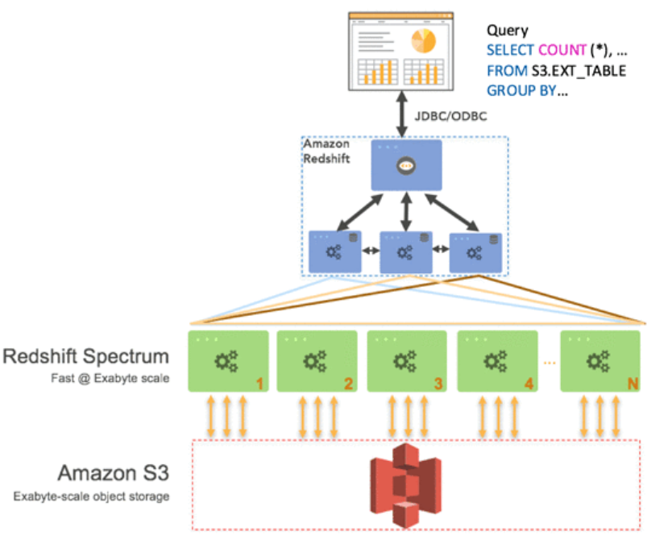

* **Enhanced VPC routing** in Amazon Redshift is a feature that forces all network traffic between your Redshift cluster and other AWS services (like Amazon S3) to be routed through your Virtual Private Cloud (VPC) instead of using the public internet.
* Enhanced VPC Routing in Amazon Redshift is a feature that forces all COPY and UNLOAD traffic between your Redshift cluster and other AWS resources, such as Amazon S3, to be routed through your Amazon Virtual Private Cloud (VPC) instead of the public internet.

**Amazon EMR**

Amazon EMR (formerly known as Amazon Elastic Map Reduce) is an **Amazon Web Services (AWS) tool for big data processing and analysis, it is based on Apache Hadoop**.

Amazon **EMR processes big data in Hadoop clusters** of virtual servers on Amazon Elastic Compute Cloud (EC2) and Amazon Simple Storage Service (S3).

Amazon EMR uses Hadoop (Hadoop cluster) on EC2 to distribute your data and processing across resizable clusters of Amazon EC2 instances.

Amazon EMR is a computing framework that runs on Hadoop. It also provides an SQL interface from Apache HIVE to query Amazon S3

**Feature of EMR**

* EMR helps creating Hadoop clusters (Big Data) to analyse and process vast amount of data
* The clusters can be made of hundreds of EC2 instances
* Also supports Apache Spark, HBase, Presto, Flink
* EMR takes care of all the provisioning and configuration
* Auto-scaling and integrated with Spot instances
* Use cases: data processing, machine learning, web indexing, big data

**EMR Node type and purchasing**

* **Master Node:** Manage the cluster, coordinate, manage health-- logn running.
* **Core Node:** Runs tasks and store data -- long running.
* **Task Node(optional):**Just to run taks-- usually spot
* **Purchase options:**
  + On-demand.
  + Spot Instances
  + Reserved instances.

**EMR vs Redshit**

**When to use Redshift**.

Redshift is used when -

* **Traditional data warehouse**
* When you **need the data relatively hot for analytics such as BI**
* When there is no data engineering team
* When your queries require joins
* When you **need a cluster 24X7**
* When you data type are simple, i.e not Arrays, or Structs
* When data has no nested jsons
* When **you have petabyte scale database**
* When you **want analize massive amount of data (spectrum)**
* When you need update/delete
* When you require and ACID DBMS

**When to use EMR**

EMR is used when -

* When you **need a transient cluster, for night or hourly automation**
* When **compute elasticity is important (auto scaling on tasks)**
* When cost is important: spot instances.
* When you **data scales until a few hundred TB’s**
* When you want to decouple compute and storage (external table + task node + auto scaling). this is cloud architecture best practice.
* When you require more flexibility
  + Complex partitions + dynamic partitioning + insert overwrite. click on the link for an example.
  + Complex data type
  + Structs
  + Arrays <–> nested json
* Orchestration built in such as Oozie, although Airflow is more common.
* Notebook built in – mix your code with SQL via Zeppelin

**Amazon Athena**

Athena helps you analyse unstructured, semi-structured, and structured data stored in Amazon S3.

Athena integrates with Amazon QuickSight for easy data visualization. Properties are-

* **Serverless query service to analyse data stored in Amazon S3**.
* **Uses standard SQL language to query the files (built on Presto)..**
* Supports CSV, JSON, ORC, Avro, and Parquet
* Pricing: $5.00 per TB of data scanned.
* Use compressed or columnar data for cost-savings (less scan).
* **Use cases**: Business intelligence / analytics / reporting, analyze & query VPC Flow Logs, ELB Logs, CloudTrail trails, etc...
* To analyze data in S3 using serverless SQL, use Athena



**Amazon Athena -- Performance Improvement**

* **Use columnar data for cost-saving (less scan means less cost)**
  + Apache Parquet or ORC is recommended.
  + Huge performance improvement.
  + Use Glue to convert your data to Parquet or ORC.
  + Compress data for smaller retrievals (bzip2, gzip, Iz4, snappy, zip, zstd..)
  + Partition datasets in S3 for easy querying on virtual columns.

**AWS Athena -- Federated Query**

* Allows you to run SQL queries across data stored in relational, non-relational, object and customs data source (AWS or on-premise)
* Use data Source Connecters that run on AWS Lambda to run Federated Queries (e.g.- CloudWatch Logs, DynamoDB, RDS..)
* Store the results from databases back into S3 for further analysis.

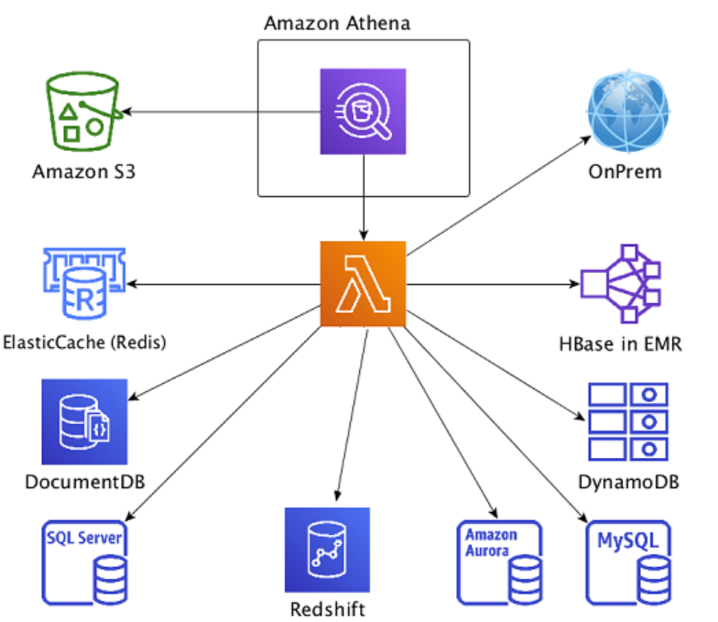

**Amazon QuickSight**

Amazon **QuickSight is BI utility to analyse the data and creates the dashboard for visualization** and decision making.

* **Serverless machine learning-powered business intelligence service to create interactive dashboards**.
* Fast, automatically scalable, embeddable, with per-session pricing.
* Integrated (can read data from to create dashboard) with RDS, Aurora, Athena, Redshift, S3…
* Use cases:
  + Business analytics
  + Building visualizations
  + Perform ad-hoc analysis
  + Get business insights using data

**DocumentDB**

Like Auroa which is designed/compatible with PostgreSQL and MySQL, **DocumentDB is mongoDB compatible database in AWS, i.e it is serverless.**

* DocumentDB is for MongoDB (which is a NoSQL database) in AWS.
* MongoDB/DocumentDB is used to store, query, and index JSON data
* Similar “deployment concepts” as Aurora
* Fully Managed, highly available with replication across 3 AZ
* Aurora storage automatically grows in increments of 10GB, up to 64 TB.
* Automatically scales to workloads with millions of requests per seconds

**Amazon Neptune**

Fully managed graph-based database.

* A popular graph dataset would be a social network/media application
* Users have friends
  + Posts have comments
  + Comments have likes from users
  + Users share and like posts…
* Highly available across 3 AZ, with up to 15 read replicas
* Build and run applications working with highly connected datasets – optimized for these complex and hard queries
* Can store up to billions of relations and query the graph with milliseconds latency
* Highly available with **replications across multiple AZs**
* Great for knowledge graphs (Wikipedia), fraud detection, recommendation engines, social networking

**AWS Glue**

AWS Glue is a **serverless data integration service** that makes it easy **for analytics users to discover, prepare, move, and integrate data from multiple sources**.

AWS Glue is a fully managed ETL (extract, transform, and load) AWS service. One of its key abilities is to analyse and categorize data.

* Managed extract, transform, and load (ETL) service
* Useful to prepare and transform data for analytics
* Fully serverless service
* Glue Data Catalog: catalog of datasets
* Application - can be used by Athena, Redshift, EMR
* **Glue Data Catalog is where permanent metadata is stored.**

**Good to know in Glue at hight level**

**Glue Job Bookmark:** prevent re-processing old data.

**Glue DataBrew:** clean and normalize data using pre-built transfromation.

**Glue Studio:** new GUI to create runs and monitor ETL jobs in Glue.

**Amazon QLDB**

QLDB stands for ”**Quantum Ledger Database”.** It is **best suites for financial application** where we want to keep each transaction history.

* A ledger is a book recording financial transactions
* Fully Managed, Serverless, High available, Replication across 3 AZ
* Used to review history of all the changes made to your application data over time
* **Immutable system**: if any entry is made then no entry can be removed or modified, cryptographically verifiable
* 2-3x better performance than common ledger blockchain frameworks, manipulate data using SQL
* Difference with Amazon Managed Blockchain: no decentralization component, in accordance with financial regulation

**AWS Lake Formation**

AWS Lake Formation is a fully managed service that simplifies the creation, security, and management of data lakes.

* Discover, cleanse, transform and ingest data into your data lake.
* Data Lake= central place to have all your data for analytics purposes.
* **Combine structured and unstructured data in the data lake.**
* Out-of-the-box source blueprints: S3, RDS, relational and NoSQL DB.
* **Fine-grained access control for your application**(row and column level)
* **Built on top of AWS Glue.**

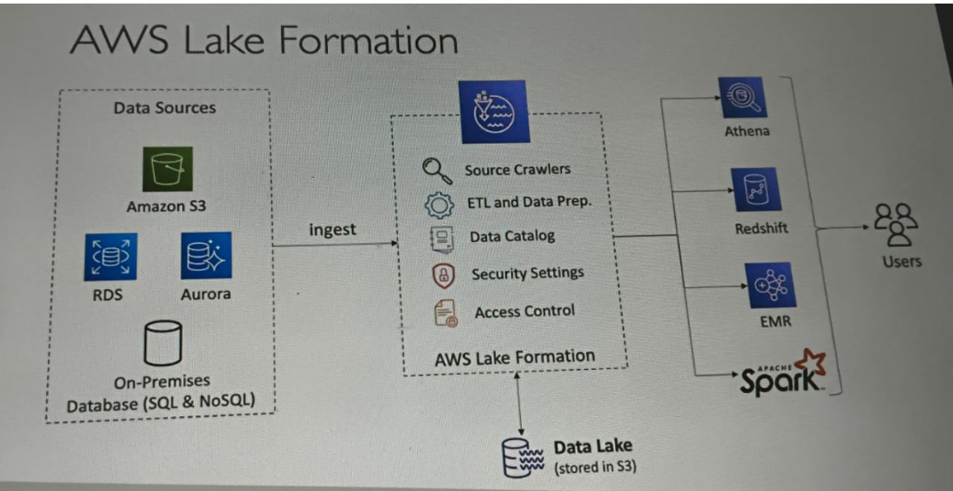

**AWS lake formation centralized permission example**

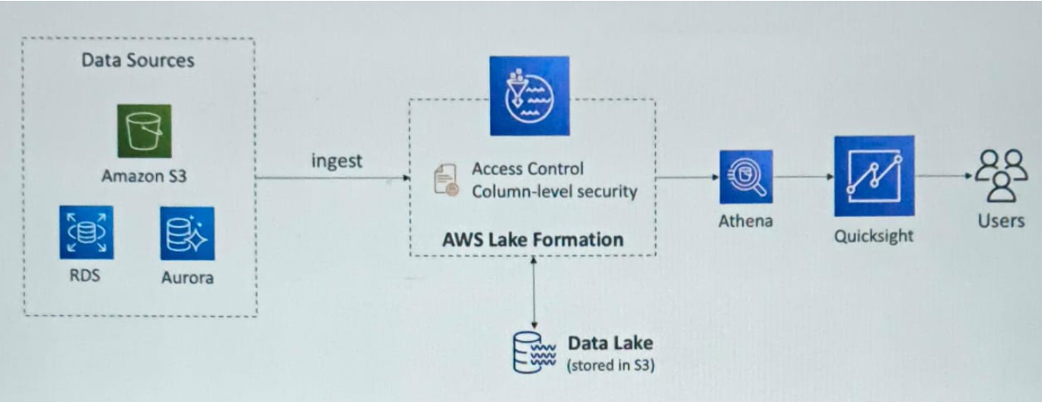

**Active-Active vs Active-Passive configuration**

**Active-Active** it involves all nodes/ server / backups active simultaneously, ensures parallel processing and high availability.

**Active-Active** In all one node/ server will be active other will be on standby.

**#Question#**

A company wants to improve resiliency of it’s application to it wants to move NoSQL db to support active-active configuration in both US East and West. Which DB service will be best-

1. AWS DynamoDB with global tables
2. AWS Aurora with multi-cluster
3. AWS RDS
4. AWS DynamoDB with DAX

Answer - A

**#######################################################################################**

**# AWS GLOBAL INFRA & ROUTE 53 #**

**#######################################################################################**

**Route 53**

The development of AWS Route 53 aimed to give developers and businesses an extremely reliable and cost-effective way to route end users to Internet applications by translating names like www.abc.com into numeric IP addresses like 192.0.1.2. The computers use this IP address to connect.

It helps in creating/registering domain regstration.



**Note:**

Amazon Route 53 can be created to perform health checks, monitor the health and performance of your web applications, web servers, and other resources. Each health check that you create can monitor one of the following:

* The health of a specified resource, such as a web server.
* The status of other health checks.
* The status of an Amazon CloudWatch alarm.
* Additionally, with Amazon Route 53 Application Recovery Controller, you can set up routing control health checks with DNS failover records to manage traffic failover for your application
* **Using route 53 we can do health checks for**

1. **HTTP/HTTPS Endpoints**
2. **TCP Connections**
3. **Amazon EC2 Instances**
4. **Elastic Load Balancers (ELBs)**
5. **Amazon S3 Bucket Website Endpoints**
6. **Amazon CloudFront Distributions**
7. **Custom Endpoints (Other Resources)**
8. **DNS Health Checks**

**DNS(Domain Name System)**

It's name that convert the alphabetical name into IP address.

* **domain name**
  + The name, such as example.com, that a user types in the address bar of a web browser to access a website or a web application.
* **Domain Registrar**
  + A company that is accredited by ICANN (Internet Corporation for Assigned Names and Numbers) to process domain registrations for specific top-level domains (TLDs)
* **Domain registry**
  + A company that owns the right to sell domains that have a specific top-level domain
* **Domain reseller**
* *A company or individual who buys domain names in bulk from a registrar and then resells them to customers for a profit.* Domain resellers essentially act as middlemen between the registrar and the end customer
* Amazon Route 53 is a domain reseller for Amazon Registrar and for our registrar associate, Gandi.
* **top-level domain (TLD)**
  + The last part of a domain name, such as .com, .org, or .eu, .gov etc. There are two types of top-level domains:
  + **Generic top-level domains**
    - These TLDs typically give users an idea of what they'll find on the website. For example, domain names that have a TLD of .bike often are associated with websites for motorcycle or bicycle businesses or organizations.
  + **Geographic top-level domains**
    - These TLDs are associated with geographic areas such as countries or cities. Some registries for geographic TLDs have residency requirements, while others, such as .io (British Indian Ocean Territory), allow or even encourage use as a generic TLD.

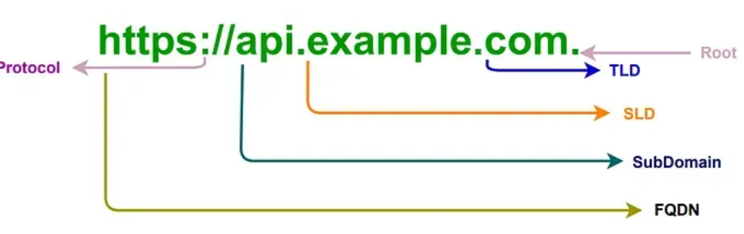

**Each record in Route 53 contains:**

* **Domain/Subdomain name** -- e.g- example.com
* **Record type** (A or AAAA)
* **Value** --- r.g.-- 12.32.45.35
* **Routing policy** --- how Route 53 responds to queries
* **TTL** --- Amount of time the record is will be cached at DNS resolvers
* Route 53 supports the following DNS record types:
  + 1.A/AAAA/CNAME/NS --- (must know)
  + 2.CAA/DS/MX/NAPTR/PTR/SOA/TXT/SPF/SRV

**Route 53 record type:**

* **A**-- Maps a hostname to IPv4
* **AAAA** -- Maps a hostname to IPv6
* **CNAME** -- maps a host name to another host name
* we can not create a CNAME for top Node of DNS

**Route 53 TTL ( Time To Live )**

* TTL is a setting that **determines the duration (in seconds) that DNS records are cached by DNS resolvers and clients.** Once a record is cached, it won’t be queried again until the TTL period expires. This caching mechanism helps reduce DNS lookup times and minimizes the load on DNS servers.
* *TTL is mandatory for each DNS record except alias record.*

|  |  |
| --- | --- |
|  | **Hight TTL -- e.g 24 hr**   * Less traffic on Route 53 * Possibly outdated record   **Low TTL -- e.g- 60 sec.**   * More traffic on Route 53 and more cost * record are outdated for less time * Easy to change record |

**CNAME vs ALIAS**

* CNAME:
  + Points a hostname to any other hostname(app.mydomain.com=> xyz.anything.com)
  + Only for Non-Root domain(aka.somethig.mydomain.com)
* ALIAS:
  + *Points a hostname to AWS resource*(app.mydomain.com=>zyz.amazonaws.com)
  + Works for root domain and non-root domain (aka mydomain.com)
  + We can not set alias record for EC2 DNS name.

**Route 53 – Alias Record Target**

* ELB, CloudFront Distributions
* API Gateway
* Elastic Beanstalk environments
* S3 websites
* VPC interface endpoints
* Global Accelerator
* Route 53 record in the same hosted zone

**Choosing Routing Policy**

**Simple routing policy** –

* Use for a single resource that performs a given function for your domain, for example, a web server that serves content for the example.com website.
* We can *create one record with single or multiple value in simple routing policy*.
* When *alias enable then it will be only for one AWS resource*.
* Can not be associated with health checks.

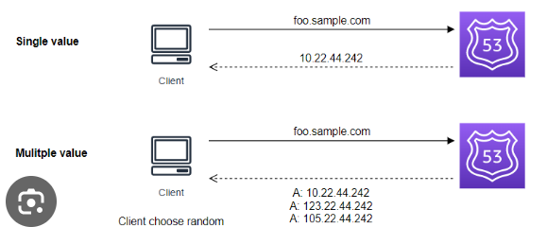

**Failover routing policy**

* Use when you want to **configure active-passive failover**.
* For one record we give two values (**primary and secondary)** in in route 53.
* If primary goes unhealthy in health check, then route 53 will automatically switch to second value.

**Geolocation routing policy**

* Use when you want to route traffic based on the location of your users. You can use geolocation routing to create records in a private hosted zone.
* In geolocation based routing policy we need to have one default value ( while creating record in Route 53) for case when a request come none of specified geolocation.

|  |  |
| --- | --- |
|  |  |

**Geo-proximity routing policy** – Use when you want to route traffic based on the location of your resources and, optionally, shift traffic from resources in one location to resources in another location. You can use geoproximity routing to create records in a private hosted zone.

* We define **the bias value ( -1 to 99 )** which defines the request routing.
  + Higher bias --- > more request goes to that region.
  + Lower bias --- > less request goes to that region.
* **Helps in routing traffic between region based on bias value**.

**Latency routing policy** – Use when you have resources in multiple AWS Regions and you want to route traffic to the Region that provides the best latency or fast response. You can use latency routing to create records in a private hosted zone.

**IP-based routing policy** – Use when you want to route traffic based on the location of your users, and have the IP addresses that the traffic originates from.

**Multivalue answer routing policy**

* Use when you want Route 53 to respond to DNS queries with up to eight healthy records selected at random.
* When routing traffic to multiple resources.
* **It’s not good choice for having ELB.**

**Weighted routing policy** –

* Use to route traffic to multiple resources in proportions that you specify, basically controls the % of resource goes to each specific resource.
* Assign each record a relative weight(**sum of weight don’t need to be 100**) :

traffic(%)= (weight for a specific record) / (sum of all the weight for all record)

|  |  |
| --- | --- |
|  | * If weight is 0 then traffic will not be sent to that resource. * If all records have weight 0 then will records will be returned equally. |

|  |  |
| --- | --- |
| **ELB**   * ELB **distributes traffic among Multiple Availability Zone but not to multiple Regions**. * ELB always routes traffic to healthy resources | **ROUTE 53**   * Route53 can distribute traffic among multiple Regions. * Route 53 may routes traffic to unhealthy resources because it have DNS caching. |

**####################################################################################**

**# AWS S3 #**

**####################################################################################**

**Amazon S3**

Amazon Simple Storage Service (Amazon S3) is an object storage service that offers industry-leading scalability, data availability, security, and performance. It’s region level and hybrid service.

S3 provides web interfaces to store files. Our data files (image files, video files, text files, etc.) are stored as **objects** within **buckets**. Buckets serve as containers for objects.

**S3 use cases: -**

* Backup and storage
* Disaster Recovery
* Archive
* Hybrid Cloud storage
* Application hosting
* Media hosting
* Data lakes & big data analytics
* Software delivery
* Static website

**Bucket**

A bucket is a container for objects (any file which we can to store) stored in Amazon S3. You can store any number of objects in a bucket and can have up to 100 buckets(can be increased on request) in your account.

* Amazon S3 allows people to store objects (files) in “buckets” (directories)
* Buckets must have a globally unique name (across all regions all accounts)
* Buckets are defined at the region level
* S3 looks like a global service but buckets are created in a region
* Naming convention-
  + No uppercase
  + No underscore
  + 3-63 characters long
  + Not an IP
  + Must start with lowercase letter or number

**Note:**

We can sync buckets in same or different region (CRR) using S3 Batch Replication.

**Objects**

Objects are the fundamental entities stored in Amazon S3. Objects consist of object data and metadata.

The metadata is a set of name-value pairs that describe the object. These pairs include some default metadata, such as the date last modified, and standard HTTP metadata, such as Content-Type. You can also specify custom metadata at the time that the object is stored.

**An object is uniquely identified within a bucket by a key (name) and a version ID**.

**Key**

An object key (or key name) is the unique identifier for an object within a bucket. Every object in a bucket has exactly one key. It is basically full path of object (stored files). E.g-

* //my-bucket/my_file.txt
* //my-bucket/my_folder1/another_folder/my_file.txt

**The combination of a bucket, object key, and optionally, version ID (if S3 Versioning is enabled for the bucket) uniquely identify each object.**

• The key is composed of **prefix** + **object name**

* s3://my-bucket/my_folder1/another_folder/my_file.txt

• There is no concept of “directories” within buckets (although the UI will trick you to think otherwise)

• Just keys with very long names that contain slashes (“/”)

• Object values are the content of the body:

* Max Object Size is 5TB (5000GB)
* If uploading more than 5GB, must use “multi-part upload”

• Metadata (list of text key / value pairs – system or user metadata)

* Tags (Unicode key / value pair – up to 10) – useful for security / lifecycle
* Version ID (if versioning is enabled)

**S3 Versioning**

You can use S3 Versioning to keep multiple variants of an object in the same bucket.

With S3 Versioning, you can preserve, retrieve, and restore every version of every object stored in your buckets if object is deleted using version id.

You can easily recover from both unintended user actions and application failures.

**Version ID**

When you enable S3 Versioning in a bucket, Amazon S3 generates a unique version ID for each object added to the bucket. Objects that already existed in the bucket at the time that you enable versioning have a version ID of null.

**S3 Secutiry**

We can configure the security ( read/ write etc access ) of s3 bucket in below way-

* **User based**

In this method we can assign role/access/policies (predefined or user defined) to IAM user who can access s3 buckets (this for user level.)

IAM policies - which API calls should be allowed for a specific user from IAM console

* **Resource Based**

In this we assign which user can access bucket and which object(s) within a bucket by creating policy using JSON file. (this is bucket level)

* + Bucket Policies - bucket wide rules from the S3 console - allows cross account
  + Object Access Control List (ACL) – finer grain(steps- bucket –> permission –> Bucket ACL )
  + Bucket Access Control List (ACL) – less common
* Note: an IAM principal can access an S3 object if-
  + The user IAM permissions allow it OR the resource policy ALLOWS it
  + AND there is no explicit DENY
* Encryption: encrypt objects in Amazon S3 using encryption keys

**S3 Bucket Policies- (kind of resource-based security/policy)**

S3 bucket policies are created in JSON file. This is most common to define access for any user.

These polices/rules are used to control the access of bucket objects and upload action (encryption on object upload ect)

When we create S3 bucket polices which is JSON file it contains below parameter.

* JSON based policies
  + **Resources**: this is basically buckets and objects
  + **Actions**: Set of API(AWS bucket permission e.g- GetObject, GetBucketAcl) to Allow or Deny
  + **Effect**: Allow / Deny
  + **Principal**: The account or user to apply the policy.
* Use S3 bucket for policy to:
  + Grant public access to the bucket
  + Force objects to be encrypted at upload
  + Grant access to another account (Cross Account)

**How to configure bucket policy:**

Go to bucket ---- > permission ------ > Bucket Policy , click on EDIT in front of it ----- > Policy generator ----- > Fill the details of form and JSON policy will be generated ---- > Copy and paste in Bucket Policy and save it.



**S3 Standard General Purpose**

* 99.99% Availability
* Used for frequently accessed data
* Low latency and high throughput
* Sustain 2 concurrent facility failures
* Use Cases: Big Data analytics, mobile & gaming applications, content distribution…

**Types of S3 storage classes**

We can divide s3 storage classes in below types-

1. S3 Infrequent access (IA)
2. One Zone-Infrequent Access (S3 One Zone-IA)
3. S3 Glacier Instant Retrieval
4. S3 Glacier Flexible Retrieval (formerly Amazon S3 Glacier)
5. S3 Glacier Deep Archive - for long term storage
6. S3 Intelligent-Tiering

We can define our storage class while uploading the files/data or can change for existing file/objects in bucket.

**Assign storage class (while uploading objects in bucket)**

Go to bucket --- > upload files ---- > properties (Select storage class)

**Assign storage class (existing objects in bucket)**

Go to bucket and object (click on object) -- > scroll down , click on Edit in front of Storage class and modify.

**S3 (Standard)Infrequent access (IA)**

S3 Standard-IA **is for data that is accessed less frequently, but requires rapid access when needed.**

* high durability, high throughput, and low latency of S3 Standard, with a low per GB storage price and per GB retrieval charge.
* 99.9% availability.
* Use cases: Disaster Recover, backup.

**Amazon S3 One Zone-Infrequent Access (S3 One Zone-IA)**

* High durability in a single Availability Zone
* 99.5% availability
* Use cases: Storing secondary backup copies of on-premise data, or data you can recreate

**Amazon S3 Glacier Instant Retrieval**

This is mainly for storing the archival data. Great for accessed data once a quarter.

* Millisecond retrieval.
* minimum storage duration of 90 days

**Amazon S3 Glacier Flexible Retrieval (formerly Amazon S3 Glacier)**

S3 Glacier Flexible Retrieval **delivers low-cost storage, up to 10% lower cost (than S3 Glacier Instant Retrieval)**, for archive data that is **accessed 1—2 times per year and is retrieved asynchronously**.

* Expedited (1 to 5 minnures), standard ( 3 to 5 minutes), bulk (5 to 12 hours)
* Minimum storage duration of 90 days

**Amazon S3 Glacier Deep Archive - for long term storage**

S3 Glacier Deep Archive is Amazon S3’s lowest-cost storage class and supports long-term retention and digital preservation for data **that may be accessed once or twice in a year**. It is designed for customers—particularly those in highly-regulated industries, such as financial services, healthcare, and public sectors—that **retain data sets for 7—10 years or longer** to meet regulatory compliance requirements

* Standard (12 hours), Bulk (48 hours)
* Minimum storage duration of 180 days

**S3 Intelligent-Tiering**

* Small monthly monitoring and auto-tiering fee
* Moves objects automatically between Access Tiers based on usage
* There are no retrieval charges in S3 Intelligent-Tiering
* Frequent Access tier (automatic): default tier
* Infrequent Access tier (automatic): objects not accessed for 30 days
* Archive Instant Access tier (automatic): objects not accessed for 90 days
* Archive Access tier (optional): configurable from 90 days to 700+ days
* Deep Archive Access tier (optional): config. from 180 days to 700+ days
* When there is random access scenario.

|  |  |  |  |  |  |  |  |  |  |  |  |  |  |  |  |  |  |  |  |  |  |  |  |  |  |  |  |  |  |  |  |  |  |  |  |  |  |  |  |  |  |  |  |  |  |  |  |  |  |  |  |  |  |  |  |  |
| --- | --- | --- | --- | --- | --- | --- | --- | --- | --- | --- | --- | --- | --- | --- | --- | --- | --- | --- | --- | --- | --- | --- | --- | --- | --- | --- | --- | --- | --- | --- | --- | --- | --- | --- | --- | --- | --- | --- | --- | --- | --- | --- | --- | --- | --- | --- | --- | --- | --- | --- | --- | --- | --- | --- | --- | --- |
| |  |  |  |  |  |  |  |  | | --- | --- | --- | --- | --- | --- | --- | --- | |  | **S3 Standard** | **S3 Intelligent-Tiering\*** | **S3 Standard-IA** | **S3 One Zone-IA†** | **S3 Glacier Instant Retrieval** | **S3 Glacier Flexible Retrieval** | **S3 Glacier Deep Archive** | | Designed for durability | 99.999999999% (11 9’s) | 99.999999999% (11 9’s) | 99.999999999% (11 9’s) | 99.999999999% (11 9’s) | 99.999999999% (11 9’s) | 99.999999999% (11 9’s) | 99.999999999% (11 9’s) | | Designed for availability | 99.99% | 99.9% | 99.9% | 99.5% | 99.9% | 99.99% | 99.99% | | Availability SLA | 99.9% | 99% | 99% | 99% | 99% | 99.9% | 99.9% | | Availability Zones | ≥3 | ≥3 | ≥3 | 1 | ≥3 | ≥3 | ≥3 | | Minimum  capacity charge per object | N/A | N/A | 128 KB | 128 KB | 128 KB | N/A | N/A | | Minimum storage duration charge | N/A | N/A | 30 days | 30 days | 90 days | 90 days | 180 days |   First  Byte millisecond millisecond millisecond millisecond millisecond Min.-Hr Hrs  Latency  Data  Retrieval NA NA per GB per GB per GB per GB per GB  Charge |
|  |

**Note:**

* There is no storage class by name S3 Random-Access. It’s just added in question for distractor.
* In call Glacier classes data is charger as – storage +retrieval charges.
* AWS S3 analytics helps to analyze access pattern and decide to create life-cycle/ transition to right storage class.

**Durability:**

It measures the probability of data loss in percentage. High durable percent means lower the chances of data loss.

Example:

S3 Standard Tier is designed for 99.999999999% durability. This means that if you store 100 billion objects in S3, you will lose one object at most.

**S3 replication**

S3 Replication is a fully-managed feature available for Amazon Simple Storage Service (S3) customers. It can automatically replicate S3 objects to another region’s bucket or same region bucket(different account also).

There are two type of Replication-

1. Corss-Region Replication (CRR)

2. Same-Region Replication (SRR)

**Note:**

S3 replication works for any bucket if versioning is enabled for that bucket.

**Cross-Region Replication (CRR)** — copies S3 objects across multiple regions , representing geographically separate Amazon data centres.

**Steps.**

Go to source bucket --- > Management (enable replication) ------> create replication rule ------ > Select bucket in another region

**Same-Region Replication (SRR)** —copies S3 objects between buckets in different availability zones (AZs), which are separate data centres in the same AR.

**Shared Responsibility Model for S3**

| **AWS** | **YOU** |
| --- | --- |
| * Infrastructure (global security, durability, availability, sustain concurrent loss of data in two facilities) | * S3 Versioning, S3 Bucket Policies, S3 Replication Setup |
| * Configuration and vulnerability analysis | * Logging and Monitoring, S3 Storage Classes |
| * Compliance validation | * Data encryption at rest and in transit |

**AWS Snow Family**

AWS Snow Family is a group of devices that transport data in and out of AWS.

The Snow Family (comprised of AWS Snowcone, Snowball, and AWS Snowmobile) oﬀers several physical devices and capacity profiles, most with built-in computing capabilities.

**Data migration**:

* Snowcone
* Snowball Edge
* Snowmobile

**Edge computing**:

* Snowcone
* Snowball Edge

**Snowball Edge (for data transfers and edge computing)**

* Snowball is secure device **used for edge computing and data transfer(in and out of AWS).**
* Physical data transport solution: move TBs or PBs of data in or out of AWS
* Alternative to moving data over the network (and paying network fees)
* Pay per data transfer job
* Provide block storage and Amazon S3-compatible object storage
* **Snowball Edge Storage Optimized**
  + 416 GB Memory and 210 TB Storage (SSD)
* **Snowball Edge Compute Optimized**
  + 416 GB Memory and 28 TB Storage (SSD)
* Use cases: large data cloud migrations, DC decommission, disaster recovery

Each Snowball Edge device **can transport data at speeds faster than the internet**. This transport is done by shipping the data in the appliances through a regional carrier. The appliances are rugged, complete with E Ink shipping labels.

**It is based choice when:**

* Have limited bandwidth.
* Limited internet connectivity
* Hight network cost.
* Shared bandwidth.
* Want to do edge computing ( for Compute Optimized SnowBall)

**Snowball into Glacier**

* Snowball does not import data directly into S3 Glacier Storage class.
* We first need to import into S3 and then create life-cycle rule to move object into Glacier class.

**AWS Snowcone**

* Small, portable computing, anywhere, rugged & secure, **for edge computing and data transfer**.
* Light (4.5 pounds, 2.1 kg)
* **Device used for edge computing, storage, and data transfe**r
* 8 TBs of usable storage
* Use SnowCone where Snowball does not fit (space-constrained environment)
* Must provide your own battery / cables
* Can be sent back to AWS offline, or connect it to internet and use AWS DataSync to send data

**AWS Snowmobile**

* Transfer exabytes of data (1 EB = 1,000 PB = 1,000,000 TBs)
* Each Snowmobile has 100 PB of capacity (use multiple in parallel)
* High security: temperature controlled, GPS, 24/7 video surveillance
* Better than Snowball if you transfer more than 10 PB

| **Properties** | **Snowcone** | **Snowball Edge Storage Optimized** | **Snowmobile** |
| --- | --- | --- | --- |
| Storage Capacity | 8 TB usable | 80 TB usable | < 100 PB |
| Migration Size | Up to 24 TB, online and offline | Up to petabytes, offline | Up to exabytes, offline |

**Edge Computing**

* Process data while it’s being created on an edge location
  + A truck on the road, a ship on the sea, a mining station underground...
* These locations may have
  + Limited / no internet access
  + Limited / no easy access to computing power
* We setup a Snowball Edge / Snowcone device to do edge computing
* Use cases of Edge Computing:
  + Preprocess data
  + Machine learning at the edge
  + Transcoding media streams
* Eventually (if need be) we can ship back the device to AWS (for transferring data for example)

**Snow Family - Edge Computing**

* SnowCone (smaller)
  + 2 CPUs, 4 GB of memory, wired or wireless access
  + USB-C power using a cord or the optional battery
* Snowball Edge – Compute Optimized
  + 52 vCPUs, 208 GiB of RAM
  + Optional GPU (useful for video processing or machine learning)
  + 42 TB usable storage
* Snowball Edge – Storage Optimized
  + Up to 40 vCPUs, 80 GiB of RAM
  + Object storage clustering available
* All(SnowCone and SnowEdge): Can run EC2 Instances & AWS Lambda functions (using AWS IoT Greengrass) and as Edge Computing
* Long-term deployment options: 1 and 3 years discounted pricing

**Comparison of SnowCone, SnowEdge and SnowMobile**

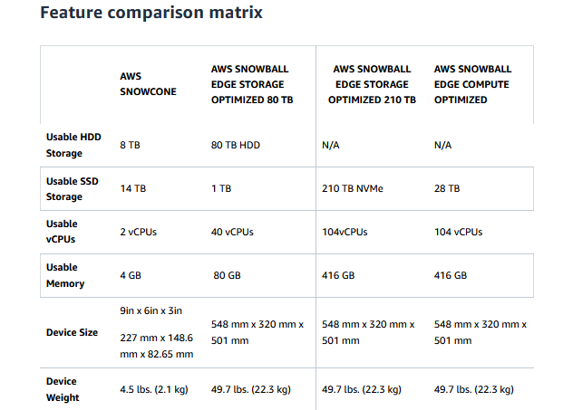

**AWS OpsHub**

AWS OpsHub is **a graphical user interface you can use to manage AWS *Snowball devices*(storage, compute)**

* Unlocking and configuring single or clustered devices
* Transferring files
* Launching and managing instances running on Snow Family Devices
* Monitor device metrics (storage capacity, active instances on your device)
* Launch compatible AWS services on your devices (ex: Amazon EC2 instances, AWS DataSync, Network File System (NFS))

**AWS S3 requestor Pays:**

* In this owner is charged for storage of object and consumer/user will be charged for object retrieval cost.
* User must be authenticated user in AWS.

**AWS S3 Event Notification**

It’ notification feature in AWS S3 when certain event occurs in S3 bucket and these events can target ANS, SQS or Lambda function.

To make this work we need to provide policy on Lambda, SQL or SNS.

|  |  |
| --- | --- |
|  | * Object removal events * Restore object events * Reduced Redundancy Storage (RRS) object lost events * Replication events * New object created events( put, post, multiple objects upload etc) |

**AWS S3 Even Notification with AWS EventBridge**

* We can *send all S3 even to EventBridge and then by applying filter/rule to EventBridge we can notify to over 18 AWS Services*
* **Advanced filtering** option with JSON rules(metadata, object size, name ..)
* **Multiple Destinations**
* **EventBridge capabilities** -- Archive , Replay events, etc

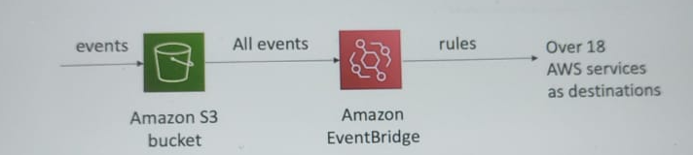

**Performance - S3 Byte-Range Fetches:**

* It **allows to parallelize GETs by requesting specific byte ranges.**
* Better resilience in case of failure.
* Can be used to speedup downloads.
* Use case: Getting only header part of file

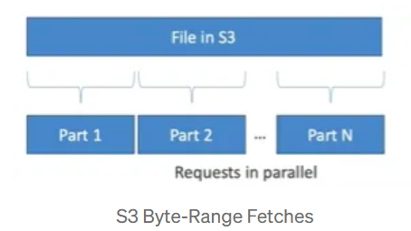

**S3 Batch Operation:**

Batch Operations **allows users to execute bulk operations on many Amazon S3 objects with just a few click.**

**Operations like:-**

* Modify object metadat and properties
* Copy object b/w S3 busckets
* Modify ACLS , tags
* Restore objects from S3 etc

**Advantage**–

* Object Management
* Saves Money and time
* Improves performance and efficiency.

**S3 - Storage Lens**

* Understand, analyze, and optimize storage across entire AWS organization.
* Discover anomalies, identify cost efficiencies, and apply data protection nest practices across entire AWS organizations (30 days usage and activity metrics)
* Aggregate data for Organization, specific account, region, bucket or prefixes.
* Default dashboard or create your own dashboard.

**###########################################################################**

**# AWS S3 Security #**

**###########################################################################**

When we create bucket in S3 , console shows options for encryption.

S3 encryption is at bucket level, i.e it encrypts all object within bucket.

We can encrypt object in S3 using any of below methods:-

1. **Server-Side Encryption (SSE)**

* Server-Side Encryption with AWS **S3-Manages Keys. (default)**
  + Encrypts objects using keys handled, managed, and owned by AWS.
* Server-Side Encryption with KMS Keys Stored in **AWS KMS(SSE-KMS)**
  + Leverage AWS Key Management Service (AWS KMS) to manage encryption keys
* Server-Side Encryption with **Customer-Provided Keys(SSE-C)**
  + When you want to manage your own encryption keys

1. **Client Encryption**

**AWS SSE S3**

* Encryption using keys **handled, managed, and owned by AWS**.
* Object is encrypted server-side and enabled by default for all object.
* Encryption type is **AES-256**.
* Must set header **"x-amz-server-side-encryption":"AES256"**

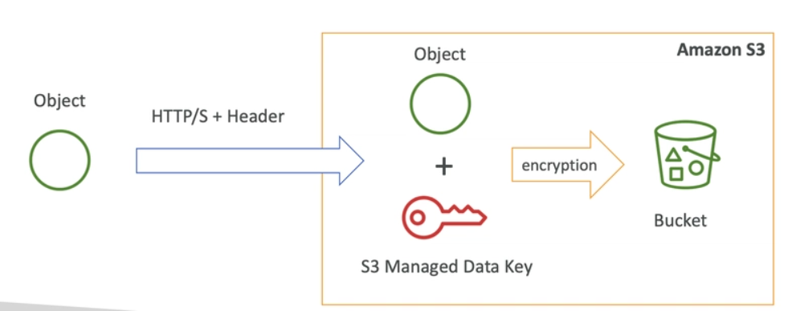

**AWS SSE KMS**

* Encryption using **keys handled, managed by AWS but owned by customer.**
* KMS advantage: *user control + audit key usage using cloud Trail*
* Must set header "x-amz-server-side-encryption";"aws:kms"
* Object is encrypted server side

|  |  |
| --- | --- |
|  | SSE-KMS limitation:   * **Count towards the KMS quota per second - (5500,10000,30000 req/s based on region) but can be increased using service quota and console**. * When uploaded, calls GenerateDataKey API. * When downloaded, calls Decrypt KMS API key. |

**SSE-C**

* Server-Side Encryption using keys fully managed by the customer outside of AWS.
* AWS S3 does not store the encryption key you provide.
* HTTPS must be used.
* Encryption key must be provided in HTTPS headers for every HTTP request.

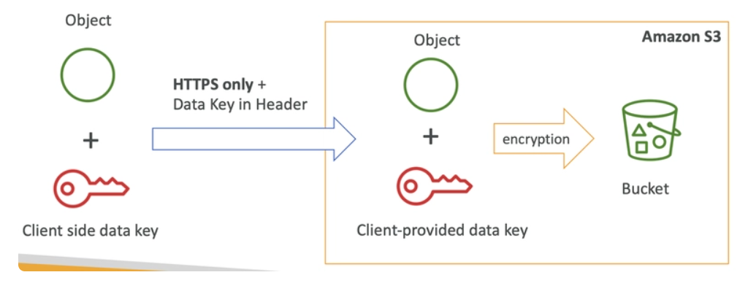

**AWS S3 Client-Side Encryption:**

* Use client libraries such as AWS S3 Client-Side Encryption Library.
* Client must encrypt data themselves before sending to AWS S3.
* Client Must decrypt data themselves when retrieving from AWS S3.
* Customer fully manages the keys and encryption-decryption.

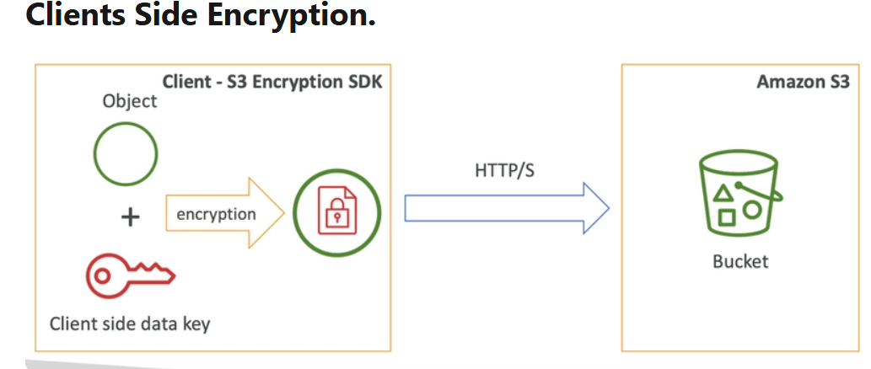

**AWS S3 Client-Side Encryption:**

* AWS S3 -- Encryptions in transit (SSL/TLS)
* Encryption in flight is also called SSL/TLS
* AWS S3 exposes two endpoints:
* HTTP endpoint -- non encrypted
* HTTPS endpoint -- encryption in flight
* HTTPS is mandatory for SSE-C

**##################################**

**# CORS – Cross Origin Resource Sharing #**

**##################################**

* *CORS defines a way for client web applications that are loaded in one domain to interact with resources in a different domain.*
* This is useful because complex applications often reference third-party APIs and resources in their client-side code.
* Origin= scheme(protocol)+host(domain)+port
  + For **HTTPS port is: 80**
  + For **HTTP port is: 443**
* Web browser-based mechanism to allow requests to other origins while visiting the main origin.
* The *other request won't be fulfilled unless the other origin allows for the requests, using CORS header.*
* If client makes a cross-origin request on our S3 bucket, we need to enable the correct CORS headers.
* You can allow for a specific origin or for *(for all origin)

|  |  |
| --- | --- |
|  | **Popular exam question.** |

**AWS S3 – MFA Delete**

* When working with S3 Versioning in Amazon S3 buckets, we can **optionally add another layer of security by configuring enable MFA (multi-factor authentication) in S3**.
* When we enable this, **AWS forces to use MFA (software on mobile or hardware) before doing important operation (suspending versioning of bucket or deleting object from bucket) on S3**.
* MFA delete is enabled then it requires two forms of authentication together for deleting or suspending bucket versioning:
  + Your security credentials
  + Token/security number from MFA device

**Note**:

1.By default, bucket MFA is disabled.

2.**MFA can be enabled on S3 bucket only using AWS CLI not by console**.

3.If enabled then object can be deleted by console but deleting the deleted marker(version) needs CLI.

**AWS S3 Log Access**

* *S3 bucket access logging stores all information on all requests made to a bucket, such as PUT, GET, and DELETE actions for authorized or unauthorized for any account. ( Disable by default )*
* The target bucket (where S3 access logs stored) bucket should be in same region.
* The logs data can be analysed using data analysis tool.

**How to enable S3 Logs**

Create bucket -- > properties -- > server access login ( enable it)

Fill the required details, e.g. – target bucket (bucket where access logs will be stored).

**AWS S3 Pre-signed URL**

By default, all Amazon S3 objects are private, only the object owner has permission to access them. However, the object owner may share objects with others by creating a pre-signed URL.

* **A pre-signed URL uses security credentials to grant time-limited permission to access objects.**
* **Using pre-Signes URL we can allow users to read, write or update object.**
* The URL can be entered in a browser or used by a program to download the object. The credentials used by the pre-signed URL are those of the AWS user who generated the URL.

**How to create it:**

*Open the bucket --- > Object action --- > share with pre-signed URL ( fill required detail, e.g- user id, pwd, life time of pre-signed URL)*

**########################################################################**

**# CloudFront #**

**########################################################################**

Amazon CloudFront is a fast content delivery network (CDN) service that securely delivers data, videos, applications etc. It is kind of caching of data on user request and then providing from cache.

Amazon CloudFront is a web service that speeds up distribution of your static and dynamic web content, such as .html, .css, .js, and image files, to your users. CloudFront delivers your content through a worldwide network of data centres called edge locations.

When a user requests content that you are serving with CloudFront, the request is routed to the edge location that provides the lowest latency (time delay), so that content is delivered with the best possible performance.

* Content Delivery Network (CDN)
* Improves read performance, content is cached at the edge
* Improves user’s experience
* 216 Point of Presence globally (edge locations)
* DDoS (global server attach) protection integration with Shield, AWS Web Application Firewall

**Mechanism of working**

* If requested object is available in edge location (already cached) then it is served from edge location else if gets retrieved from origin, cached into edge and server from edge.
* Edge location will be decided as nearest location to end user.



**S3 Transfer Acceleration**

S3 Transfer Acceleration is a service that speeds up, simplifies, and secures file transfers between one client and an S3 bucket.

Transfer Acceleration uses Amazon CloudFront's globally dispersed edge sites to accelerate file transfers. When data arrives at an edge point, it is routed through an efficient network path to the Amazon S3 service. When the Transfer acceleration service is employed, the user incurs additional expenses.

In simple terms it is basically a way of transferring file from client to browser and vice versa to a temporary location(using users network) and then from there to required region (using AWS network) to make the file transfer quick.

**Example:**

Let say we want to transfer file to bucket in Australia region using S3 transfer acceleration. It will happened in below way-

**File in USA -> Edge Location(USA) -> S3 Bucket(Australia)**

**AWS Global Accelerator**

Let take a case that we have deployed our application in India and it’s global application. Now if any client who is accessing the application is as much far from India will experience that much of latency. To overcome this AWS introduced global accelerator.

AWS Global Accelerator is a service that allows you to route traffic to your applications using the AWS global network (AWS infrastructure) instead of the internet.

Global Accelerator (GA) provides you with two public static IP addresses that users can connect to in order to reach your application endpoint. GA then optimises the path from those IP addresses to your application which results in lower latency and better network performance.

* Improve global application availability and performance using the AWS global network
* Leverage the AWS internal network to optimize the route to your application (60% improvement)
* 2 Anycast IP are created for your application and traffic is sent through Edge Locations
* The Edge locations send the traffic to your application

**Note**:

Global Accelerator is best fit for non-HTTP use case.

**AWS Global Accelerator vs CloudFront**

* They both use the AWS global network and its edge locations around the world
* Both services integrate with AWS Shield for DDoS protection.
* **CloudFront – Content Delivery Network**
  + Improves performance for your cacheable content (such as images and videos)
  + Content is served at the edge
* **Global Accelerator**
  + No caching, proxying packets at the edge to applications running in one or more AWS Regions.
  + Improves performance for a wide range of applications over TCP or UDP
  + **Good for HTTP use cases** that require static IP addresses
  + Good for HTTP use cases that required deterministic, fast regional failover

**AWS OutPosts**

AWS outposts is hybrid cloud service. In this AWS installs the server (racks) on-premise and these on-premise servers works like AWS servers.

AWS Outposts are “server racks” that offers the same AWS infrastructure, services, APIs & tools to build your own applications on-premises just as in the cloud

* AWS will setup and manage “Outposts Racks” within your on-premises infrastructure and you can start leveraging AWS services on-premise.
* You are responsible for the Outposts Rack physical security.

**Benefits of Outposts**

* Low-latency access to on-premises systems
* Local data processing
* Data residency
* Easier migration from on-premises to the cloud
* Fully managed service
* Some services that work on Outposts are-
  + EC2, EBS, EFS, ECS
  + S3
  + EKS
  + RDS
  + EMR

**AMAZON FSx**

AWS FSx ***helps us to launch and run high-performance 3rd party file systems on AWS***.

This is fully managed service and it have various types as -

* FSx for Lusture
* FSx for Windows File Server
* FSx for NetApp ONTAP
* FSx for OpenZFS

**AWS FSx for Windows (File Server)**

* FSx for Windows is a fully managed Windows file system share drive.
* Supports ***SMB protocol & Windows NTFS***.
* ***Supports Microsoft Active Directory integration, ACLs, user quotas***.
* Scales upto 10s of GB/s, millions or IOPS, 100s PB of data.
* Storage option:
  + SSD
  + HDD
* **Can be access from your on-premise infrastructure** (VPS or Direct Connect)
* Can be **configured to Multi-AZ**(high availability)
* Data is **backed up daily to S3**.

**Amazon FSx for Lusture**

* The name Lusture is derived from Linux and Clusture.
* Lusture is a type of **parallel distributed file system, for large-scale computing**.
* Used for **machine learning or High-Performance Computing**.
* Scales to 100s of GB/s, millions of IOPS, sub-ms latencies.
* Storage Option:
  + SSD
  + HDD
* Seamless **integration with S3**
* Can be ‘read S3’ as a file system ( through FSx)
* **Can write the output of the computation back to S3**(through FSx)
* **Can be used from on-premise servers** (VPN or Direct Connect)

**FSx File System deployment option (Lusture)**

* **Scratch File System**
  + *Temporary storage*
  + Data is not replicated (does not persist if file server fails)
  + High Burst (6x faster, 200MBps per TiB)
  + Usage: short -term processing, optimise cost.
* **Persistent file system:**
  + *Long-term storage*
  + Data is replicated within same AZ.
  + If FSx server fails it is replicated within minutes.
  + Usage: long-term processing, sensitive data

|  |  |
| --- | --- |
| **Scratch deployment** | **Persistent deployment** |

**FSx NetApp ONTAP**

* Manages NetApp ONTAP on AWS
* File system compatible with NFS, SMB, iSCI protocol
* Move workloads running on ONTAP or NAS to AWS.
* Works with:
* Linus, Windows, MacOS, VMWare Cloud on AWS
* AWS Workspaces and Appstream 2.0, AWS EC2, ECS and EKS
* Point in time instantaneous cloning.

**FSx NetApp ONTAP**

* Managed OpenZFS file system on AWS.
* File system compatible with NFS
* Move workloads running on ZFS to AWS.
* Works with:
* Linus, Windows, MacOS, VMWare Cloud on AWS
* AWS Workspaces and Appstream 2.0, AWS EC2, ECS and EKS

**FSx NetApp ONTAP**

* Managed OpenZFS file system on AWS.
* File system compatible with NFS
* Move workloads running on ZFS aws.
* Works with:
* Linus, Windows, MacOS, VMWare Cloud on AWS
* AWS Workspaces and Appstream 2.0, AWS EC2, ECS and EKS
* Scales to 1 million IOPS.

**AWS Storage Gateway**

AWS Storage Gateway is a **service that connects an on-premises software appliance with cloud-based storage** to provide seamless and secure integration between your on-premises IT environment and the AWS storage infrastructure in the AWS Cloud. e.g.- S3

S3 is AWS proprietary storage system but we can expose it to on-premise using Storage Gateway.

* **Use cases:**
  + Disaster recovery
  + backup and restore.
  + Tiered Storage.
  + On-premise cache and low-latency file access(for frequently needed data)

**Types of Storage Gateway**

* S3 File Gateway
* FSx File Gateway
* Volume Gateway
* Tape Gateway

**S3 File Gateway**

Configures S3 buckets are accessible using NFS and SMB protocol.

Most frequently used data is cached in the file gateway.

Supports S3 Standard, S3 Standard IA, One Zone A, S3 Intelligent Tiering.

Transition to S3 Glacier using a Life Cycle Policy

Bucket access using IAM role for each file gateway.

SMB protocol had integration with AD for user authentication.

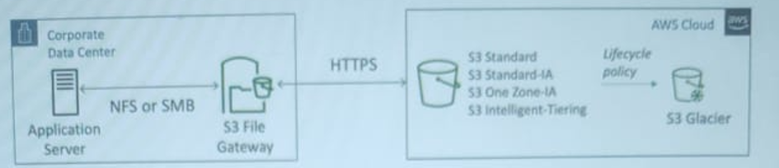

**Volume Gateway**

* Block storage using iSCSI protocol backed by S3.
* Backed by EBS snapshots which can help restore on-premise volumes.
* **Cached volumes:** low latency access to most recent data.
* **Stored volumes:** entire dataset is on premise, scheduled backups to S3.

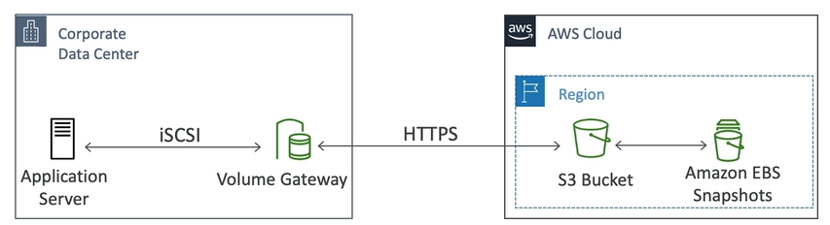

**AWS transfer family**

A fully-manages service for file transfer into and out of AWS S3 or AWS EFS using the FTP protocol.

Supported Protocols

* AWS Transfer to FTP (File transfer protocol)
* AWS Transfer for FTPS (File transfer protocol over SSL FTPS)
* AWS Transfer for SFTP (Secure file transfer protocol)

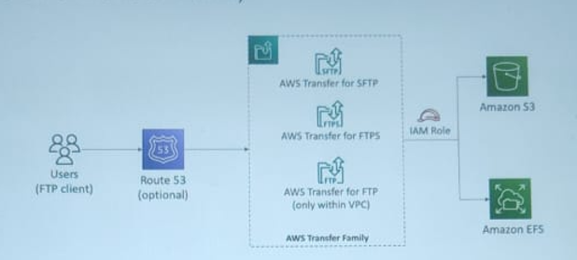

**AWS DataSync**

* It is used to move large amount of data **from on-premise to AWS or AWS to AWS Storage services (same or cross region)**.
* Can synchronize to: Amazon S3(any storage classes- including Glacier), Amazon EFS, Amazon FSx for Windows.
* Replication tasks can be scheduled (not contunous) hourly, daily, weekly.
* The replication tasks are incremental after the first full load.
* Can synchronise to:
  + AWS S3
  + AWSEFS
  + AWS FSx(Windows, Lusture, NetApp, OpenZFS)



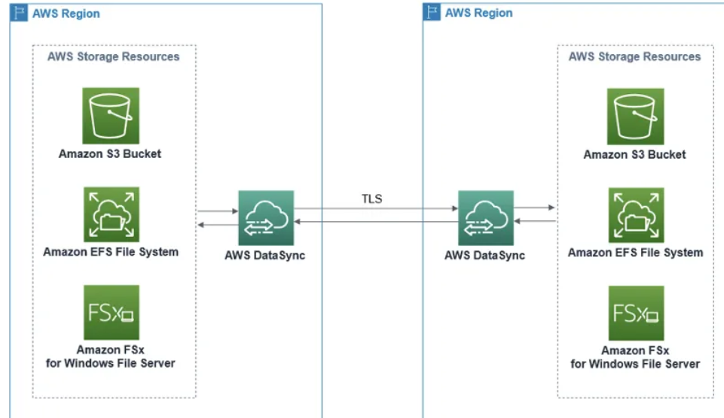

**###########################################################################**

**# SNS, SQS and MQ #**

**###########################################################################**

Let say we deployed application then they need to communicate with one another, communication between them can be categorised in two type-

1. **Synchronous communication** (application to application)
2. **Asynchronous/event-based** Communication (application -- que -- application)

If communication is synchronous then problematic in some cases, like- if there are sudden spikes of traffic. Thus, we need to decouple synchronous communication(build loosely coupled system or make asynchronous) and use some other models-

1. **SQS**: queue model, *serverless service*

* FIFO (First In First Out queue)
* Standard Queue (message are delivered in random order)

1. **SNS**: pub/sub model, *serverless service*
2. **Kinesis**: real-time data streaming model (out of scope for the exam)

**SQS Model**

Amazon SQS is a distributed queue system that enables web service applications to quickly and reliably queue messages that one component in the application generates to be consumed by another component where a queue is a temporary repository for messages that are awaiting processing.

With the help of SQS, you can send, store, and receive messages between software components at any volume without losing messages.

Once the message is read/delivered then that message is deleted from queue.

**SQS in webserver/application example**



**Kinesis**

* Kinesis = real-time big data streaming
* Managed service to collect, process, and analyze real-time streaming data at any scale
* Too detailed for the Cloud Practitioner exam but good to know:
  + Kinesis Data Streams: low latency streaming to ingest data at scale from hundreds of thousands of sources
  + Kinesis Data Firehose: load streams into S3, Redshift, ElasticSearch, etc…
  + Kinesis Data Analytics: perform real-time analytics on streams using SQL
  + Kinesis Video Streams: monitor real-time video streams for analytics or ML

**Kinesis Data Stream vs Kinesis Data Firehose**

|  |  |  |
| --- | --- | --- |
| **Feature** | **Kinesis Data Streams** | **Kinesis Data Firehose** |
| Purpose | **Real-time data processing** | **Data loading to AWS destinations** |
| Control | High (custom consumers, manual scaling) | Low (fully managed, automatic scaling) |
| Latency | Low | Higher (due to buffering) |
| Transformations | More complex transformations possible | Basic transformations supported |
| Management | Manual scaling | Automatic scaling |
| Complexity | More complex | Simpler |

**Dead-Letter Que**

A dead-letter queue (DLQ) is **a special type of message queue that temporarily stores messages that a software system cannot process due to errors**.

It acts as temporary storage for erroneous and failed messages. DLQs prevent the source queue from overflowing with unprocessed messages.

**SQS – Message Visibility timeout**

Let’s consider a case that message is received in Que and all consumers processing the same message then it may create business issue ( i.e – sending same notification multiple times, same message processed any multiple EC2, Lambda etc), to avoid it we have 'Message Visibility timeout'.

* It is the **time window in which message will not be visible to other consumers in case if one consumer is processing it.**
* **If within that time window consumer is unable to process and delete from que then it will be visible to another consumer and other consumer may process it**.
* If it was able to processed by consumer then it will be deleted from que and will not be visible by another consumer.
* **Consumer may change the visibility timeout in case if it is going to take time time(on fly).**
* **30 sec – default visibility timeout.**

**Long Polling and Short Polling**

When consumer poll for message in Que and consider there is no message in que then –

1. Consumer can wait for certain time (1 to 20 sec) for next poll **-- Long Polling**
2. Do not’ wait for and poll immediately into que for message **– Shot polling**

* *Long polling* ***decreases the number of API calls made to SQS while increasing the efficiency*** *and reducing latency of your application*.
* ***Long polling can be enabled at the queue level or at the API level*** **using** **WaitTimeSeconds**.

**SQS – FIFO Queue**

* First in first out messaging queue, messages are processed in order.
* Limited throughput – 300 msg/sec without batching and 3000msg/sec with batching.
* No Duplicate message processing.

**SQS with Auto Scaling Group (ASG)**

We can configure ASG with SQS (basically as consumer) to always have sufficient resource to processed messages.

e.g – add one more EC2 instance when there are 1000 or more message in queue.

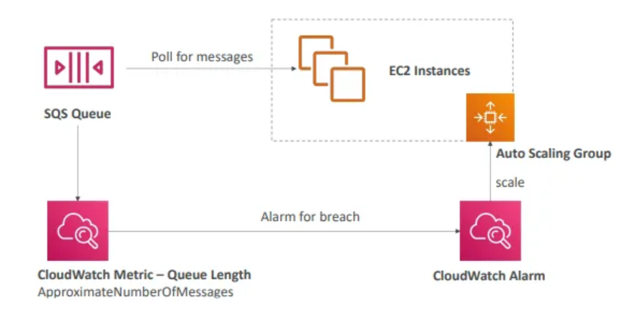

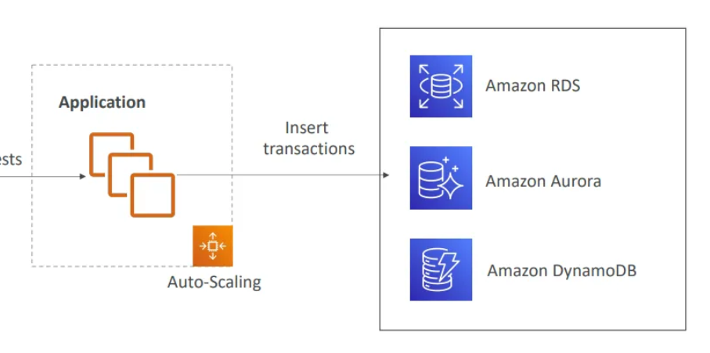

**Use case:** Updating the order tables, based on SQS.

**SNS (Simple Notification Service)**

* What if you want to send one message to many receivers (e.g- sending whether update of upcoming rain, cyclone, thunder)
* In **this publisher send message to SNS topic and from topic it is send to subscriber, who have subscribed it.**
* Amazon Simple Notification Service is a notification service provided as part of Amazon Web Services since 2010. It provides a low-cost infrastructure for mass delivery of messages, predominantly to mobile users.
* The “event publishers” only sends message to one SNS topic
* As many “event subscribers” as we want to listen to the SNS topic notifications
* Each subscriber to the topic will get all the messages
* Up to 12,500,000 subscriptions per topic, 100,000 topics limit

It is not designed to send/receive messages between two software component. It is for sending notification to users.

|  |  |
| --- | --- |
| **SQS**   * Basically, designed for communication between software component. * One message processed for one resource. * SQS follows pull mechanism where messages/notifications are being pulled from the queue. | **SNS**   * Basically, designed for communicating directly to end user. * One message for many resource(shopping offer notification). * SNS follows push mechanism where subscribers receive messages/notifications instantly. |

**SNS can receive notification from various service** –

* lambda, DynamoDB, RDS event, CloudWatch Alarm, ASG,
* CloudFormation, AWS Budget, S3 Buckets and so on.

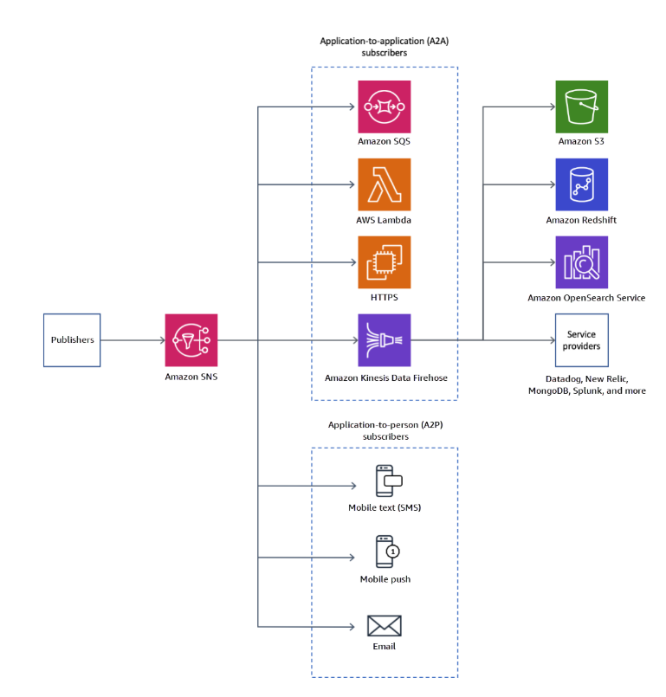

**Encryption:**

* In-Flight encryption using HTTPS API.
* At-rest encryption using KMS keys.
* Client-side encryption if the client wants to perform encryption/decryption itself.

**Access Control:**

* IAM policies to regulate access to SNS API.
* SNS access policies, useful for cross account SNS topic.

**Amazon MQ**

* *SQS, SNS are “cloud-native” services, and they are using proprietary protocols from AWS*.
* *Traditional applications running from on-premise may use open protocols such as: MQTT, AMQP, STOMP, Openwire, WSS, MQ*
* When migrating to the cloud, instead of re-engineering the application to use SQS and SNS, we can use Amazon MQ
* Amazon MQ = managed Apache ActiveMQ
* Amazon MQ doesn’t “scale” as much as SQS / SNS
* Amazon MQ runs on a dedicated machine (not serverless)
* Amazon MQ has both queue feature (~SQS) and topic features (~SNS)

**Monolithic Application:**

In monolithic system applications are tightly coupled and that is not suggestable.

**##########################################################################**

**# Containers on AWS – ECS, Fargate, ECR and EKS (Other Compute engine) #**

**##########################################################################**

**Docker**

Docker is **popular virtualization software that helps its users in developing, deploying, monitoring, and running applications in a Docker Container with all their dependencies**.

Docker containers **include all dependencies (frameworks, libraries, etc.)** to run an application in an efficient and bug-free manner.



**Virtual environment vs Docker**

|  |  |  |
| --- | --- | --- |
|  | Docker | Virtual Machines (VMs) |
| **Boot-Time** | Boots in a few seconds. | It takes a few minutes for VMs to boot. |
| **Runs on** | Dockers make use of the execution engine. | VMs make use of the hypervisor. |
| **Memory Efficiency** | No space is needed to virtualize, hence less memory. | Requires entire OS to be loaded before starting the surface, so less efficient. |
| **Isolation** | Prone to adversities as no provisions for isolation systems. | Interference possibility is minimum because of the efficient isolation mechanism. |
| **Deployment** | Deploying is easy as only a single image, containerized can be used across all platforms. | Deployment is comparatively lengthy as separate instances are responsible for execution. |
| **Usage** | Docker has a complex usage mechanism consisting of both third party and docker managed tools. | Tools are easy to use and simpler to work with. |

* Docker is a software development platform to deploy apps
* Apps are packaged in containers that can be run on any OS
* Apps run the same, regardless of where they are run
  + Any machine
  + No compatibility issues
  + Predictable behaviour
  + Less work
  + Easier to maintain and deploy
  + Works with any language, any OS, any technology
* Scale containers up and down very quickly (seconds)

**Where Docker images are stored**

* Docker images are stored in Docker Repositories
* **Public: Docker Hub** https://hub.docker.com/
* Find base images for many technologies or OS:
  + Ubuntu
  + MySQL
  + NodeJS, Java…
* **Private: Amazon ECR** **(Elastic Container Registry- store, manage, deploy container images** )

**ECS -- Amazon Elastic Container Service**

Amazon Elastic Container Service (Amazon ECS) is a container management service that can quickly launch/start, exit/stop, and manage docker containers in a cluster. Some feature are-

* Launch Docker containers on AWS
* **You must provision & maintain the infrastructure** (the EC2 instances)
* **AWS takes care of starting / stopping containers**
* Has integrations with the Application Load Balancer

**Fargate**

AWS Fargate is a technology that you can use with Amazon ECS to run containers without having to manage servers or clusters of Amazon EC2 instances.

Farget is container management services where we don’t need to maintain infrastructure (EC2)

* Launch Docker containers on AWS
* You do not provision the infrastructure (no EC2 instances to manage) – simpler!
* Serverless offering
* AWS just runs containers for you based on the CPU / RAM you need

**Launch types of AWS ECS**

ECS can be launched in two following modes: -

**Fargate launch:** As discussed above, the fargate launch type, takes most of the responsibility from the users and takes in only the basic inputs like the CPU type**,** memory, and IAM policies from the user to run the application cluster.

**EC2 Launch:** This is a more customizable launch type. Users are responsible for the number of instances in the cluster, scaling their cluster, and more. This allows you to be more in control of your clusters which may be required for security reasons

|  |  |
| --- | --- |
|  |  |

**AWS ECS --- EC2 Launch Type**

* ECS= Elastic Container Service.
* Launch Docker container on AWS=Launch ECS tasks on ECS Custer.
* EC2 Launch Type: you must provision and maintain the infrastructure (the EC2 instance)
* Each EC2 instance must run the ECS agent to register in the ECS Cluster.
* AWS takes care of starting/stopping container.

Basically, in cluster of EC2 instance we deploy ECS Agent and ECS.

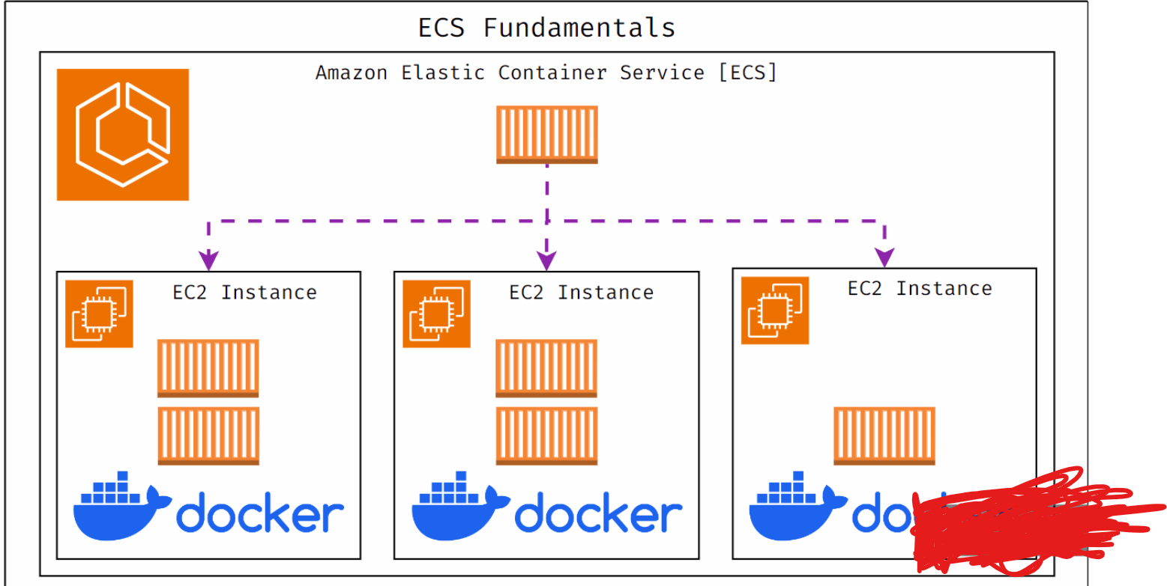

**AWS ECS – Load Balancer Integration**

* Application Load Balancer supported and works for most use cases.
* Network Load Balancer, recommended for high throughput/high performance use case or to pair it with AWS private link.
* Classic Load Balancer supported but not recommended(no advanced features- no Faregate)

**AWS ECS -- Data Volume (EFS)**

* Mount EFS file system onto ECS tasks.
* **Works for both EC2 and Fargate launch types.**
* Task running in the any AZ will share the same data in the EFS file system.
* Fargate + EFS=Serverless
* Use case: persistent multi-AZ shared storage for your containers.

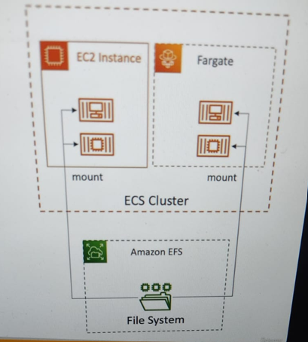

**ECS Service Auto Scaling**

Automatic scaling is the ability to increase or decrease the desired **number of tasks** in your Amazon ECS service automatically.

**Amazon ECS Auto Scaling uses AWS Application Auto Scaling-**

* ECS Service Average CU utilization
* ECS Service Average Memory Utilization- Scale on RAM
* ALB Request count per target- metric coming from the ALB.

**Target tracking**: - Scale based on target value for a specific CloudWatch metric.

**Step Scaling**: - scale based on a specific CloudWatch Alarm.

**Schedule Scaling**: - scale based on a specified date/time (predictable changes)

**ECS Service Auto Scaling (task level) <>EC2 Auto Scaling (EC2 instance level)**

**Fargate Auto Scaling is much easier to setup (because serverless)**

**EC2 Launch Type - Auto Scaling EC2 Instances**

Automate ECS service scaling by adding underlying EC2 instance

* Auto Scaling group Scaling
* Scale your ASG based on CPU utilization
* Add EC2 instance over time

**ECS Cluster Capacity provider**

Used to automatically provision and scale the infrastructure for your ECS tasks.

* Capacity provider paired with and Auto Scaling Group
* Add EC2 Instance when you are missing capacity (CPU,RAM)

**ECS with EventBridge**

We can invoke ECS tasks based on EventBridge by integrating ECS with EventBridge.

We can receive the event on EventBridge in case if any ECS task is completed/exited.

Let’s take some examples of ECS integrated with EventBridge.

**ECS integrated with S3 bucket ( for put operation)**

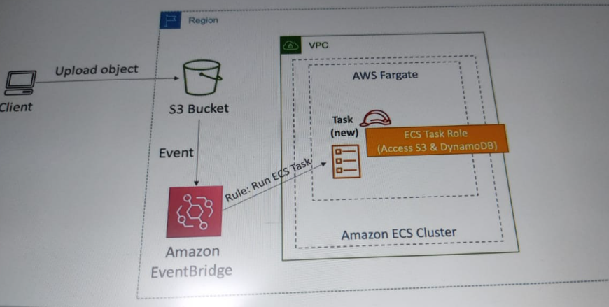

**ECS with schedule operation**

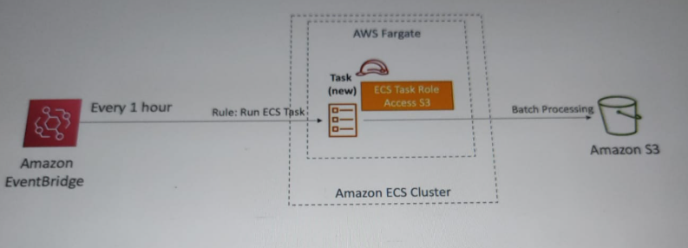

ECS with SQS

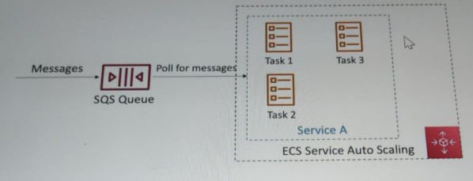

**AWS ECR**

ECR=Elastic Container Registry

* Store and manage Docker images on AWS.
* Private and public repository.
* Fully integrated with ECS, backed by AWS S3.
* Access is controlled through IAM (permission errors=>policy).
* Supports image vulnerability scanning, versioning, image tags, image life cycle etc.

**Amazon EKS Overview**

AWS EKS => Amazon Elastic Kubernetes services

* It is a way to launch manages Kubernetes cluster on AWS.
* Kubernetes is an open-source system for automatic deployment, scaling and management of containerized (usually Docker) application.
* It's as alternative to ECS, similar goal but different API.
* EKS Supports EC2 if you want to deploy worker nodes or Fargate to deploy serverless containers.
* Use case: If a company already using Kubernetes on-premise or in another cloud, and want to migrate to AWS using Kubernetes.
* Kubernetes is cloud-agnostic (can be used in any cloud-Azure, GCP ..)

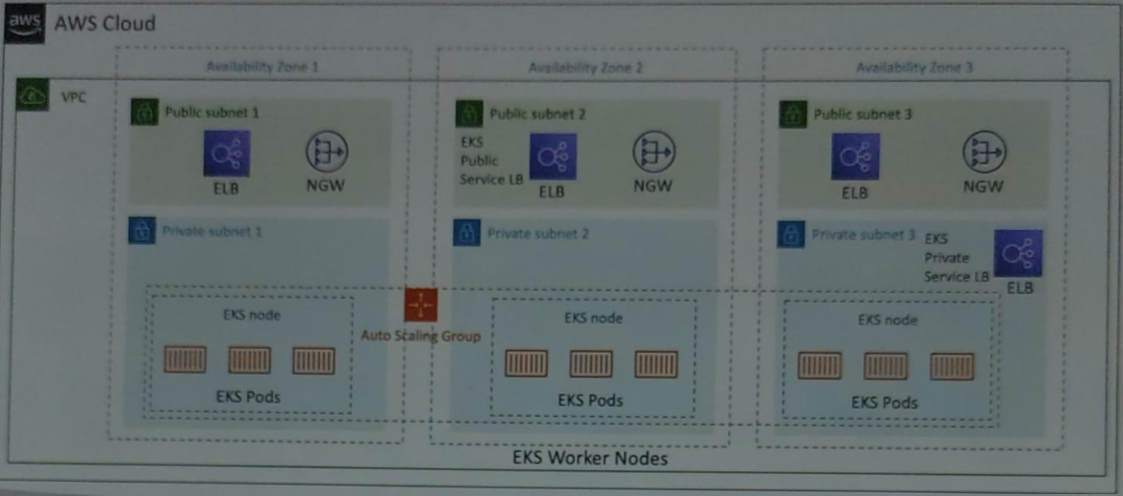

**Amazon EKS - Node Types**

1. **Manages Node Groups**

* Creates and manages Nodes (EC2 instances) for you.
* Nodes are part of an ASG managed by EKS.
* Supports on-demand or Spot Instances.

1. **Self-Managed Nodes**

* Nodes created by you and registered to the EKS cluster and manages by and ASG.
* You can use prebuilt AMI - AWS EKS Optimized AMI
* Supports On-Demand or Spot Instances.

**AWS App Runner**

* Fully managed service that makes it easy to deployment and scaling of containerized web applications and APIs.
* No infrastructure experience needed.
* Start with your source code or container image.
* Automatically scaling, highly available, load balancer, encryption.
* VPC access support.
* Connect to DB, cache, and message queue services.

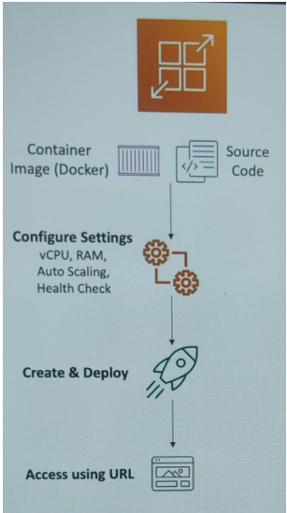

**App2Container**

AWS App2Container (A2C) is a command-line tool that simplifies the process of containerizing and migrating existing .NET and Java applications to AWS.

**######################################################################################**

**# SERVERLESS IN AWS #**

**######################################################################################**

**What is serverless**

AWS offers services where we don’t need to provision or manage servers called as serverless services.

**Serverless Compute services**

* Lambda
* Fargate

**Serverless Storage services**

* S3
* EFS, EBS

**Serverless Database Services**

* DynamoDB, Aurora

**Serverless Api and Messaging Services**

* API Gateway
* SNS, SQS

**Serverless Analytics Services**

* Kinesis
* Athena

**Serverless Application Integration & Orchestration**

* EventBridge
* Step Function

**AWS lambda**

AWS Lambda is an event-driven, serverless computing platform provided by Amazon as a part of Amazon Web Services.

In AWS Lambda the code is executed based on the response of events in AWS services such as add/delete files in S3 bucket, HTTP request from Amazon API gateway, etc.

It is used for short time running jobs.

**AWS Lambda vs EC2**

| **EC2** | **Lambda** |
| --- | --- |
| Virtual Servers in the Cloud | Virtual functions – no servers to manage! |
| Limited by RAM and CPU | Limited by time - short executions |
| Continuously running | Run on-demand(event occurrences) |
| Scaling means intervention to add / remove servers | Scaling is automated! |

**Benefit of AWS Lambda**

* Easy Pricing:
  + Pay per request and compute time
  + Free tier of 1,000,000 AWS Lambda requests and 400,000 GBs of compute time
* Integrated with the whole AWS suite of services
* Event-Driven: functions get invoked by AWS when needed
* Integrated with many programming languages
* Easy monitoring through AWS CloudWatch
* Easy to get more resources per functions (up to 10GB of RAM!)
* Increasing RAM will also improve CPU and network!

**Lambda Container Image**

* The container image must implement the Lambda Runtime API.
* ECS/Fargate is preferred for running arbitrary Docker images.

**AWS Batch**

AWS Batch is a service that lets you run batch jobs in AWS.

We can define the time for each job when it should run.

It offers queues where we can send jobs and queue could be configured with a certain priority to run jobs.

**Features of AWS Batch**

* Fully managed batch processing at any scale
* Efficiently run 100,000s of computing batch jobs on AWS
* A “batch” job is a job with a start and an end (opposed to continuous)
* Batch will dynamically launch EC2 instances or Spot Instances
* AWS Batch provisions the right amount of compute / memory
* You submit or schedule batch jobs and AWS Batch does the rest!
* Batch jobs are defined as Docker images and run on ECS
* Helpful for cost optimizations and focusing less on the infrastructure

**AWS lambda vs Batch**

| **Batch** | **Lambda** |
| --- | --- |
| No time limit | Time limit (15 min ) |
| Any runtime as long as it’s packaged as a Docker image | Limited runtime |
| Rely on EBS / instance store for disk space | Limited temporary disk space |
| Relies on EC2 (can be managed by AWS), not serverless | Serverless |
| Not limited by programming language. | Limited by programming language |

**AWS LightSail**

Amazon Lightsail is lightweight AWS services for light weight application, for beginners.

Amazon Lightsail is with Amazon Web Services (AWS) for developers who need to build websites or web applications. It includes everything you need to launch your project quickly - instances, container services, managed databases.

**Features of LigthSail:** the easiest way to get started

* Virtual servers, storage, databases, and networking
* Low & predictable pricing
* Simpler alternative to using EC2, RDS, ELB, EBS, Route 53…
* Great for people with little cloud experience!
* Can setup notifications and monitoring of your Lightsail resources
* Use cases:
  + Simple web applications (has templates for LAMP, Nginx, MEAN, Node.js…)
  + Websites (templates for WordPress, Magento, Plesk, Joomla)
  + Dev / Test environment
* Has high availability but no auto-scaling, limited AWS integrations

**Integration of Lambda with Other Services ( most commonly used)**

* API Gateway
* Kinesis
* DynamoDB
* S3
* CloudFront
* CloudWatch Events, EventBridge
* CloudWatch logs
* SNS, SQS
* Cognito

**Deployement:**

* Lambda function deployment size (compressed .zip): 50 MB
* Size of uncompressed deployment (code + dependencies): 250 MB
* Can use the /tmp directory tp load other files at startup

**Limitation:**

* Memory allocation: 128 MB - 10GB (1MB increments)
* Maximum execution time: 900 seconds (15 minutes)
* Env variables (4 KB)
* Disk capacity in the "function container" (in/tmp) 512 MB to 10 GB
* Concurrency executions: 1000 (can be increased)

**Edge Function**

Edge functions are tools to add custom logic at the edge location with CloudFront.

Edge functions allow to enrich applications while reducing latency, and build fully distributed applications.

We don’t need to manage any server, it’s serverless.

* A code that we write and attach to CloudFront distribution.
* Runs close to your users to minimize latency.

**Edge function types:**

* 1. CloudFront Functions
  2. Lambda@Edge

**Lambda@Edge**

Lambda@Edge is a feature of Amazon CloudFront that lets you run code closer to users of your application, which improves performance and reduces latency.

**CloudFront Functions**

CloudFront Functions are a serverless compute service offered by AWS that allows you to run lightweight JavaScript code at Amazon CloudFront's edge locations

|  |  |  |
| --- | --- | --- |
|  | **CloudFront Functions** | **Lambda@Edge** |
| Programming languages | JavaScript (ECMAScript 5.1 compliant) | Node.js and Python |
| Event sources | Viewer request | Viewer request |
| Viewer response | Viewer response |
|  | Origin request |
|  | Origin response |
| [Supports Amazon CloudFront KeyValueStore](https://docs.aws.amazon.com/AmazonCloudFront/latest/DeveloperGuide/kvs-with-functions.html) | Yes | No |
|  |
| [CloudFront KeyValueStore only supports JavaScript runtime 2.0](https://docs.aws.amazon.com/AmazonCloudFront/latest/DeveloperGuide/functions-javascript-runtime-20.html) |
| Scale | Up to millions of requests per second | Up to 10,000 requests per second per Region |
| Function duration | Submillisecond | Up to 5 seconds (viewer request and viewer response) |
|  |
| Up to 30 seconds (origin request and origin response) |
| Maximum function memory size | 2 MB | 128 MB (viewer request and viewer response) |
|  |
| 10,240 MB (10 GB) (origin request and origin response) |
|  |
| [For more information, see Quotas on Lambda@Edge.](https://docs.aws.amazon.com/AmazonCloudFront/latest/DeveloperGuide/cloudfront-limits.html#limits-lambda-at-edge) |
| Maximum size of the function code and included libraries | 10 KB | 50 MB (viewer request and viewer response) |
|  |
| 50 MB (origin request and origin response) |
| Network access | No | Yes |
| File system access | No | Yes |
| Access to the request body | No | Yes |
| Access to geolocation and device data | Yes | No (viewer request and viewer response) |
|  |
| Yes (origin request and origin response) |
| Can build and test entirely within CloudFront | Yes | No |
| Function logging and metrics | Yes | Yes |

**Note:**

By default, lambda does not work with VPC. To make it working we need to provide VPC id , Elastic Network Interface (ENI) then it will works.

**Lambda with RDS Proxy**

If lambda function directly accesses our database, then may open too many coactions under hight load so we should prefer to use RDS proxy.

The lambda function must be deployed in our PVC, because RDS proxy is never publicly accessible.

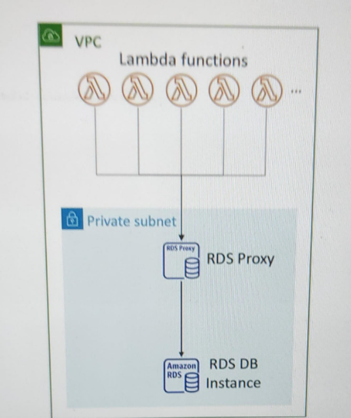

**API Gateway**

* Amazon API Gateway is a fully managed service that makes it easy for developers to create, publish, maintain, monitor, and secure APIs at any scale.
* APIs act as the "front door" for applications to access data, business logic, or functionality from your backend services.
* Using API Gateway, you can create RESTful APIs and WebSocket APIs that enable real-time two-way communication applications.
* API Gateway supports containerized and serverless workloads, as well as web applications.

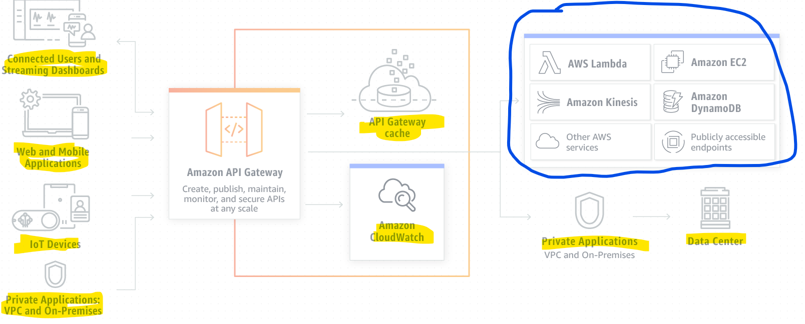

**#########################################################################**

**### Database in AWS ##**

**#########################################################################**

**Database Types (Sort summary)**

* **RDBMS (SQL/OLTP):** RDS, Aurora -- Great for joins
* **NoSQL db (no joins, no sql)**: DynamoDB(~json), ElasticCache (key/value pair), Neptune(graphs), DocumentDB (for MongoDB), Keyspaces (for Apache Cassandra)
* **Object Store:** S3(for big objects)/Glacier (for backups/archives)
* **Data Warehouse (=SQL Analytics/BI)**: Redshift (OLAP), Athena, EMR
* **Search:** OpenSearch (JSON)-- free text, unstructured searched
* **Graphs:** Amazon Neptune -- displays relationships between data
* **Ledger:** Amazon Quantum Ledger Database
* **Time Series:** Amazon timestream

**Key Features of Amazon Aurora**

* **Aurora Serverless** -- for unpredictable/intermittent workloads, no capacity planning.
* **Aurora Global**: Upto 16 DB Read Instances in each region, <1 second storage replication.
* **Aurora Database** Cloning: New cluster from existing one, faster than restoring a snapshot.

**Proprietary AWS Database:**

* Fully managed relational database compatible with MySQL and PostgreSQL.

**Performance Boost:**

* Up to 5x faster than MySQL.
* Up to 3x faster than PostgreSQL.

**Storage Auto-Scaling:**

* Automatically scales in 10GB increments.
* Max capacity: 128TB.

**High Availability:**

* Replicates data across 3 Availability Zones.
* Maintains 6 copies of your data for durability.
* Automated failover in under 30 seconds.

**Replication & Read Scaling**

* Supports up to 15 read replicas.
* Low replication lag (~10ms).
* Cross-region replication available for global apps and disaster recovery.
* Instant failover to replicas if the primary fails.

**Cost & Efficiency**

* Slightly more expensive than RDS (~20% higher), but offers better performance and reliability.
* Ideal for mission-critical workloads needing high throughput and low latency.

**Aurora Global Database**

* Designed for globally distributed applications.
* Enables fast local reads in multiple regions.
* Replicates data without impacting performance.

**Architecture & Management**

* Master-replica model: One master, multiple read replicas.
* Replicas can be promoted to master if needed.
* Fully managed by AWS: handles backups, patching, scaling, and monitoring.

**ElastiCache Database Summary**

* In memory data store, sub-millisecond latency.
* Supports for clustering (Redis) and Multi AZ, read replica.
* Security through IAM, Security Group, KMS and Redis Auth.
* Backup, backup and point in time restore feature.
* Managed and schedule maintenance.

**⚡ What Is Amazon ElastiCache?**

* **Fully managed in-memory data store** and caching service.
* Supports **Redis** and **Memcached** engines.
* Designed to **boost application performance** by reducing database load and latency.

**🚀 Key Features**

* **High Performance**:
  + Microsecond latency for read-heavy workloads.
  + Ideal for real-time apps like gaming leaderboards or analytics.
* **Scalability**:
  + **Vertical scaling**: Increase node size.
  + **Horizontal scaling**: Add more nodes (sharding for Redis, clustering for Memcached).
* **High Availability**:
  + **Multi-AZ deployments** with automatic failover (Redis only).
  + **Global Datastore** for cross-region replication (Redis).
* **Security**:
  + **SSL encryption** in transit.
  + **Redis AUTH** and **Memcached SASL** for authentication.
  + VPC integration for network isolation.

**🧠 Redis vs. Memcached Comparison**

| **Feature** | **Redis** | **Memcached** |
| --- | --- | --- |
| Data Structures | Rich (lists, sets, hashes, etc.) | Simple key-value |
| Persistence | Yes (AOF, snapshots) | No |
| Replication | Yes (read replicas) | No |
| Multi-threading | No | Yes |
| Backup & Restore | Supported | Not supported |
| Use Case | Complex data, session store | Simple caching, high-speed KV |

**🔄 Caching Patterns**

* **Lazy Loading**: Cache data only after it's requested.
* **Write-Through**: Update cache and DB simultaneously.
* **Session Store**: Store temporary session data with TTL.

**✅ Common Use Cases**

* **Database query caching** to reduce load.
* **Session management** for scalable web apps.
* **Real-time analytics** and **leaderboards**.
* **Geospatial data** for location-based services (Redis).

**DynamoDB Summary**

* **Fully managed NoSQL database** service by AWS.
* Designed for **low-latency, high-throughput** workloads.
* Supports **key-value** and **document** data models.
* **Serverless**: No infrastructure to manage.
* **Can Replace ElasticCache** as key/value pair store(storing session data )
* **Highly available, Mutli-AZ** by default Read and Writes are decoupled, transaction capability.
* **DAX cluster for read cache, microsecond read latency.**
* **Security, authentication, and authorization is done through IAM**.
* Event processing: DynamoDB Streams to integrate with AWS lambda or Kinesis Data Stream.
* Global Table feature: active-active setup
* Automated backups upto 35 days with PITR (restore to new table) or on-demand backup.

**🔑 Core Features**

* **Primary Keys**:
  + **Partition key only** (simple key).
  + **Partition + sort key** (composite key).
* **Secondary Indexes**:
  + **LSI** (Local Secondary Index): Alternate sort key.
  + **GSI** (Global Secondary Index): Alternate partition/sort key.
* **Capacity Modes**:
  + **Provisioned**: Set read/write units.
  + **On-Demand**: Pay-per-request, auto-scales.

**🚀 Performance & Scaling**

* **Single-digit millisecond latency**.
* **SSD-backed storage** for speed.
* **Automatic horizontal scaling**.
* **DAX (DynamoDB Accelerator)**:
  + In-memory cache for microsecond reads.
  + Ideal for read-heavy workloads.

**🌍 Global & Real-Time Features**

* **Global Tables**:
  + Multi-region replication.
  + Active-active architecture.
* **DynamoDB Streams**:
  + Captures item-level changes.
  + Triggers **AWS Lambda** for real-time processing.

**🔒 Security & Reliability**

* **IAM-based access control**.
* **Encryption at rest and in transit**.
* **Point-in-time recovery** and **on-demand backups**.
* **Time to Live (TTL)**: Auto-expire items.

**✅ Common Use Cases**

* **Mobile apps**, **IoT**, **gaming**, **real-time analytics**.
* **Session management**, **leaderboards**, **shopping carts**.
* **Event-driven architectures** with Lambda.

**Comparison of RDS, ElastiCache and DynamoDB**

**🧠 Quick Comparison Table**

| **Feature** | **ElastiCache** | **RDS** | **DynamoDB** |
| --- | --- | --- | --- |
| Type | In-memory data store (cache) | Relational database | NoSQL key-value/document database |
| Engines | Redis, Memcached | MySQL, PostgreSQL, Oracle, etc. | Proprietary AWS engine |
| Use Cases | Fast caching, session store | Traditional transactional systems | High-scale apps, IoT, real-time data |
| Performance | Microsecond latency | Millisecond latency | Single-digit millisecond latency |
| Scalability | Vertical & horizontal (Redis) | Limited vertical & read replicas | Fully serverless, auto-scaling |
| High Availability | Redis with Multi-AZ failover | Multi-AZ, read replicas | Global tables, automatic failover |
| Persistence | Optional (Redis only) | Yes | Yes |
| Backup & Restore | Manual snapshot (Redis) | Automated backups | Point-in-time recovery |
| Pricing Model | Instance-based | Instance-based | On-demand or provisioned throughput |

**🧩 Key Takeaways for the Exam**

* ElastiCache is used to **speed up performance** by caching frequently accessed data, not as a primary data store.
* RDS is best for **structured data** with relational integrity — think legacy apps and enterprise systems.
* DynamoDB excels in **scalable, low-latency workloads** like mobile, gaming, or IoT with seamless scaling and global replication.

**S3 Summary as DB**

* S3 is a key/value store for objects.
* Great for bigger objects, not so great for many small objects.
* **Serverless, scales infinitely, max object size is 5 TB, versioning capability**.
* Tiers: S3 standard, S3 infrequent access, S3 intelligent, S3 glacier etc. +lifecycle policy.
* Features: Versioning, Encryption, Replication, MFA-Delete, Access Logs.
* Security: IAM, Bucket policies, ACL, Access points, Object Lambda, CORS, Object/Vault Lock.
* Encryption: SSE-S3, SSE-KMS, SSE-C, Client-Side, TLS in transit, default encryption.
* **Batch Operations**: On Batch using S3 batch, listing files using S3 inventory.
* Performance: Multi-part upload, S3 Transfer Acceleration, S3 Select.
* Automation: S3 Event Notification (SNS, SQS, Lambda, EventBridge)
* Use cases: static files, key value store for big files, website hosting.

**Amazon Keyspaces Summary**

Amazon Keyspaces is a **fully managed, serverless database service that’s compatible with Apache Cassandra**, designed to run scalable and highly available NoSQL workloads on AWS

* Amazon Keyspaces (for Apache Cassandra)
* **Apache Cassandra is an open-source NoSQL distributes database.**
* A managed Apache Cassandra-compatible database service.
* Serverless, Scalable, highly available, full managed by AWS.
* Tables are replicated 3 times across multi-AZ.
* Using the Cassandra Query Language (CQL)
* Single digit millisecond latency at any scale, 1000s of request per second.
* Capacity: On-demand mode for previsioned mode with auto-scaling.
* Encryption, backup, Point-In-Time Recovery (PITR) upto 35 days.
* Use case: store IoT device info, time-series data..

**🧩 Popular Distributed Databases**

| **Database** | **Type** | **Key Features** | **Used By / For** |
| --- | --- | --- | --- |
| **Apache Cassandra** | NoSQL | Peer-to-peer architecture, high write throughput | Netflix, Uber, Spotify |
| **MongoDB** | NoSQL | Sharding, replication, flexible document model | Content management, IoT, analytics |
| **CockroachDB** | SQL | Strong consistency, geo-distribution | Financial services, SaaS platforms |
| **Amazon DynamoDB** | NoSQL | Fully managed, on-demand scaling | Serverless apps, gaming, IoT |
| **Google Spanner** | SQL | Global consistency, horizontal scaling | Enterprise-grade apps |
| **TiDB** | SQL | MySQL-compatible, hybrid transactional/analytical | Real-time analytics, e-commerce |
| **YugabyteDB** | SQL | PostgreSQL-compatible, distributed transactions | Multi-region apps, fintech |
| **FoundationDB** | Multi-model | ACID compliance, fault tolerance | Apple (internal use) |
| **Apache HBase** | NoSQL | Built on Hadoop, column-oriented | Big data workloads |

**Amazon Timestream**

* Fully managed, fast, scalable, serverless time series database.
* Automatically scales up/down to adjust capacity.

**#######################################################################################**

**# Machine Learning #**

**#######################################################################################**

For AWS CCP certification we need to know about below AWS machine learning services.

* Amazon Rekognition – regional service
* Amazon Transcribe
* Amazon Polly
* Amazon Translate
* Amazon Lex & Connect
* Amazon Lex: (same technology that powers Alexa)
* Amazon Connect
* Amazon Comprehend
* Amazon SageMaker
* Amazon Forecast
* Amazon Kendra
* Amazon Personalize
* Amazon Textract

**####################**

**# Amazon Recognition #**

**###################**

* Find objects, people, text, scenes in images and videos using ML
* **Facial analysis and facial search to do user verification, people counting**
* Create a **database of “familiar faces”** or compare against celebrities
* **Use cases:**
  + Labelling
  + Content Moderation
  + Text Detection
  + Face Detection and Analysis (gender, age range, emotions…)
  + Face Search and Verification
  + Celebrity Recognition
  + Pathing (e.g. sports game analysis)

**Amazon Recognition -- Content Moderation**

* Detect content that is **inappropriate, unwanted, or offensive (Image or Video)**
* Used in social media, broadcast media, advertising, and e-commerce situation to create a safer user experience.
* Set a minimum confidence threshold for items that will be flagged.
* Flag sensitive content for manual review in Amazon Augmented AI(A2I)
* Help comply with regulation.

**###################**

**# Amazon Transcribe #**

**###################**

* Automatically convert **speech to text**.
* Uses a deep learning process called **automatic speech recognition (ASR) to convert speech to text** quickly and accurately.
* Automatically removing PII using Redaction.
* Automatically Language Detection and Transcribe.
* **Use cases-**
  + transcribe customer service calls
  + automate closed captioning and subtitling
  + generate metadata for media assets to create a fully searchable archive

**##############**

**# Amazon Polly #**

**##############**

* Turn text into lifelike speech using deep learning
* Allowing you to create applications that talk

**AWS Polly – Lexicon and SSML**

* Amazon Polly Lexicons and **SSML (Speech Synthesis Markup Language) are features that allow you to customize the text-to-speech output**.
* Lexicons enable you to control how specific words are pronounced, while SSML allows you to add various speech effects and attributes like emphasis, intonation, and pauses.

**##################**

**# Amazon Translate #**

**##################**

* Natural and accurate **language translation**.
* Amazon Translate allows you to **localize content translation**- such as websites and applications - for international users, and to easily translate large volumes of text efficiently.

**######################**

**# Amazon Lex #**

**######################**

* Automatic Speech Recognition (ASR) to **convert speech to text**
* **Natural Language Understanding to recognize the intent of text, callers**
* Helps build chatbot, call centre bots

**#################**

**# Amazon Connect #**

**#################**

* Receive calls, create contact flows, cloud-based virtual contact centre
* Can integrate with other **CRM systems or AWS**
* No upfront payments, 80% cheaper than traditional contact centre solutions

**#####################**

**# Amazon Comprehend #**

**#####################**

* For Natural Language Processing – NLP
* Fully managed and serverless service
* Uses machine learning to find insights and relationships in text
  + Language of the text
  + Extracts key phrases, places, people, brands, or events
  + Understands how positive or negative the text is
  + Analyses text using tokenization and parts of speech
  + Automatically organizes a collection of text files by topic
* **Sample use cases-**
  + analyze customer interactions (emails) to find what leads to a positive or negative experience
  + Create and groups articles by topics that Comprehend will uncover

**###################**

**# Amazon SageMaker #**

**###################**

* Fully managed service for developers / data scientists to build ML models
* Typically, difficult to do all the processes in one place + provision servers
* Machine learning process (simplified): predicting your exam score

**#################**

**# Amazon Forecast #**

**#################**

* Fully managed service that uses ML **to deliver highly accurate forecasts**
* Example: predict the future sales of a raincoat
* 50% more accurate than looking at the data itself
* Reduce forecasting time from months to hours
* Use cases: Product Demand Planning, Financial Planning, Resource Planning,etc.

**################**

**# Amazon Kendra #**

**################**

* Fully managed document search service powered by Machine Learning
* **Extract answers from within a document** (text, pdf, HTML, PowerPoint, MS Word, FAQs…)
* Natural language search capabilities
* Learn from user interactions/feedback to promote preferred results (Incremental Learning)
* Ability to manually fine-tune search results (importance of data, freshness, custom,etc..)

**###################**

**# Amazon Personalize #**

**###################**

* Fully managed **ML-service to build apps with real-time personalized recommendations**
* Example: personalized product recommendations/re-ranking, customized direct marketing
* Example: User bought gardening tools, provide recommendations on the next one to buy
* Same technology used by Amazon.com
* Integrates into existing websites, applications, SMS, email marketing systems, …
* Implement in days, not months (you don’t need to build, train, and deploy ML solutions)
* Use cases: retail stores, media and entertainment

**#################**

**# Amazon Textract #**

**################**

* Automatically extracts text, handwriting, and data from any scanned documents using AI and ML
* Extract data from forms and tables
* Read and process any type of document (PDFs, images, …)
* Use cases:
  + Financial Services (e.g., invoices, financial reports)
  + Healthcare (e.g., medical records, insurance claims)
  + Public Sector (e.g., tax forms, ID documents, passports)

**#######################################################################################**

**# Monitoring #**

**#######################################################################################**

**CloudWatch**

Amazon CloudWatch is a service used for monitoring and observing resources/services (all AWS services) in real-time.

CloudWatch collects monitoring and operational data in the form of logs, metrics, and events, providing its users with an aggregated view of AWS resources, applications, and services that run on AWS.

The CloudWatch can also be used to detect anomalous behaviour in the environments, set warnings and alarms, visualize logs and metrics side by side, take automated actions and troubleshoot issues.

* CloudWatch provides metrics for every service in AWS
* Metric is a variable to monitor (CPU Utilization, Network Ioad etc..)
* Metrics have timestamps
* Can create CloudWatch dashboards of metrics

**Important Metrics**

* EC2 instances: CPU Utilization, Status Checks, Network (not RAM)
  + Default metrics every 5 minutes
  + Option for Detailed Monitoring ($$$): metrics every 1 minute
* **EBS volumes**: Disk Read/Writes
* **S3 buckets**: BucketSizeBytes, NumberOfObjects, AllRequests
* **Billing**: Total Estimated Charge (only in us-east-1)
* **Service Limits**: how much you’ve been using a service API
* **Custom metrics**: push your own metrics

**Amazon CloudWatch Metrics**

* CloudWatch provides metrics for every service in AWS.
* Metric is available to monitor many parameters (e.g.- CPU utilization, Cost, Billing)
* Metric belongs to namespaces.
* Dimension is an attribute of metric (instance id, environment, etc.)
* Upto 30 dimension per metric.
* Metric have timestamps.
* Can create CloudWatch dashboards of metrics.
* Can create CloudWatch Customs Metrics (e.g.- for the RAM)

**CloudWatch Metric Streams**

* Continually stream CloudWatch metric to a destination of your choice, with near-real-time delivery and low latency.
* We can stream is using Amazon Kinesis Data Firehose(and then it's destinations)
* We can send Metric to 3rd party service provide: Datadog, dynatrace, new Relic, Splunk, Sumo logic etc.
* Collect the CloudWatch metric and integrate with Firehose.

**Terminology of AWS CloudWatch Metrics**

#### **Metrics**

* **It represents a time-ordered set of data points of AWS resources that are published to Amazon CloudWatch**
* All data point is marked with a timestamp
* Metric is a variable that is monitored and data points are the value of that variable over time
* They are uniquely defined by a name, namespace, and zero or more dimensions
* Metric math is used to query multiple CloudWatch metrics and use math expressions to create new time-series based on these metrics

#### **Dimensions**

* A dimension is a name/value pair which uniquely identifies a metric
* Dimensions are the unique identifiers for a metric, so whenever you add a unique name/value pair to one of the metrics, you are creating a new variation of that metric.

#### **Statistics**

* Statistics are metric data aggregations over specified periods of time
* The few available statistics on CloudWatch are maximum, minimum, sum, average, and sample count.

#### **Alarm**

* It is used to automatically initiate actions on our behalf. It collects metric from AWS services.
* It watches a single metric over a specified time and performs one or more specified actions based on the value of the metric
* The estimated AWS charges can also be monitored using the alarm

#### **Percentiles**

* It represents the relative weightage of the data in a dataset
* It helps the user to get a better understanding of the distribution of metric data

#### **Cloudwatch dashboard (monitory and observing point from definition)**

* A user-friendly CloudWatch console is available which is used for monitoring resources in a single view.
* There is no limit on the number of CloudWatch dashboards you can create.
* **These dashboards are global and not region-specific**

#### **Cloudwatch agent**

* It is required to be installed
* It collects logs and system-level metrics from *EC2 instances and on-premises servers*

#### **Cloudwatch Events:**

* **Cloudwatch events help you to create a set of rules that match with any event(i.e stopping of EC2 instance, user login etc). ---- Sample paper**
* These events can be routed to one or more targets/actions, like **AWS Lambda functions, Amazon SNS Topics, Amazon SQS queues, and other target types**.
* Cloudwatch Events observes the operational events continuously and whenever there is any change in the state of the event, it performs the action by sending notifications, activating lambda, etc.
* An **event indicates a change in the AWS environment**. Whenever there is a change in the state of AWS resources, events are generated.
* **Rules** are used for matching events and routing to targets.
* **Target** process events. They include Amazon EC2 instances, AWS Lambda functions, etc. A target receives the events in JSON format.

#### **Cloudwatch logs:**

* Amazon CloudWatch logs enable you to store, monitor, and access files from AWS resources like Amazon EC2 instances, Route53, etc.
* It also helps you to troubleshoot your system errors and maintain the logs in highly durable storage.
* It also creates log of information about the DNS queries that Route 53 receives

By default CloudWatch billing metric is stored in US East(N. Virginia) - -- us-east-1

**CloudWatch Alarm**

CloudWatch Alarm is used to send notification and take action (if defined) whenever a required condition is achieved in AWS. On various Metric.

* Alarms are used to trigger notifications for any metric
* Alarms actions…
  + Auto Scaling: increase or decrease EC2 instances “desired” count
  + EC2 Actions: stop, terminate, reboot or recover an EC2 instance
* SNS notifications: send a notification into an SNS ( invoke lambda from SNS for scaling etc)
* Various options (sampling, %, max, min, etc…)
* Can choose the period on which to evaluate an alarm
* **Example**: create a billing alarm on the CloudWatch Billing metric
* Alarm States: OK. INSUFFICIENT_DATA, ALARM

**CloudWatch Composite Alarm**

* CloudWatch Alarm are on a single metric but composite alarm is combined of many CloudWatch alarm.
* Composite Alarms are monitoring the state for multiple other alarms into a single, logical alarm.
* It uses boolean logic (AND, OR, NOT) to determine when the composite alarm should trigger.
* Helpful to reduce the "alarm noise" by creating complex composite alarms.
* Example: Trigger the alarm only when - CPU is high but network is not high.

**CloudWatch Logs**

CloudWatch Logs enables you to centralize the logs from all of your systems, applications, and AWS services that you use, in a single, highly scalable service

* CloudWatch Logs can collect log from:
  + **AWS CloudTrail**: Logs API activity and events within your AWS account.
  + **AWS Lambda**: Logs from Lambda function invocations.
  + **Amazon EC2**: System and application logs from EC2 instances (typically using the CloudWatch Agent).
  + **Amazon S3**: Access logs from S3 buckets.
  + **Amazon Route 53**: DNS query logs.
  + **Amazon VPC Flow Logs**: Network traffic logs within your Virtual Private Cloud.
  + **Amazon API Gateway**: Access logs and execution logs for API Gateway.
  + **AWS Elastic Beanstalk**: Application and system logs from Elastic Beanstalk environments.
  + **Amazon Kinesis Data Streams**: Logs from Kinesis Data Streams.
  + **AWS CloudFront**: Access logs for CloudFront distributions.
  + **Elastic Load Balancing (ELB)**: Access logs from Application Load Balancers (ALBs) and Classic Load Balancers (CLBs).
  + **Amazon RDS**: Database logs for various database engines.
  + **Amazon ECS and EKS**: Container and application logs from containers running on ECS and EKS.
* Enables real-time monitoring of logs
* Adjustable CloudWatch Logs retention
* CloudWatch logs can send log to:
  + S3 (exports)
  + Kinesis Data stream, Kinesis Data Firehose
  + AWS Lambda
  + Open Search
* CloudWatch logs are encrypted by default.
* Can be setup KMS based encryption with your own keys.

**CloudWatch Log Key Terms:**

**Log Streams:** (sequence of log events from an application in simple at one place– one log file)

* Instances within application/log files/ containers.
* Sequences of log events from a single source, like an EC2 instance or a Lambda function.

**Log Groups:**(collection of log stream, in simple – log files)

* Arbitrary name, usually representing an application.
* Collections of logs with shared retention, monitoring, and access control settings.

**Log Events:**

* Individual log entries containing timestamps and messages.

**CloudWatch log source**

* SDK, CloudWatch Logs Agent, CloudWatch Unified Agents.
* Elastic Beanstalk: collection of logs from application.
* ECS: collection of logs from containers.
* AWS Lambda: collection from function logs.
* VPC Flow logs: VPC specific logs.
* API Gateway
* CloudTrail Based on filter
* Route53: Log DNS queries

**Cloudwatch logs insight**

* Search and analyze log data stored in CloudWatch logs.
* It uses three query languages:-
  + Logs Insights query language (Logs Insights QL)
  + OpenSearch Service Piped Processing Language (PPL)
  + OpenSearch Service Structured Query Language (SQL)
* Example: Searching for count of "ERROR"

**CloudWatch Logs for EC2**

* By default, no logs from your EC2 instance will go to CloudWatch
* You need to run a CloudWatch agent on EC2 to push the log files you want
* Make sure IAM permissions are correct
* The CloudWatch log agent can be setup on-premises too

**CloudWatch Log Agent and CloudWatch Unified Agent**

* Both tools used to collect metrics and logs from EC2 and on-premises servers.
* The Unified Agent collects a wider range of system-level metrics, including custom metrics, and offers better performance and support across different operating systems.
* **CloudWatch Log Agent**
  + Older version.
  + Can only send to CloudWatch Logs
* **CloudWatch Unified Agent**
  + Collect additional system-level metrics such as RAM, processes etc..
  + Collects logs to send to CloudWatch logs.
  + Centralized configuration using SSM Parameters Store.

**Amazon EventBridge (Formerly CloudWatch Events) --- Sample Paper**

EventBridge is a **serverless service that enables you to build event-driven applications** by routing events from various sources. E.g-- AWS services, SaaS applications, and your own applications, to specified targets..

AWS EventBridge Schedular is serverless task that simplifies creating, executing and managing millions of schedules across AWS services.

* EventBridge is the next evolution of CloudWatch Events
* **Default event bus**: Receive Event generated by AWS services (CloudWatch Events)
* **Partner event bus**: Receive *events from partner SaaS service or applications* (Zendesk, DataDog, Segment, Auth0…)
* **Custom Event buses:** for your own applications
* Schema Registry: model event schema
* Trigger lambda function, send SNS/SQS message..
* **Event pattern**: Event rule to react to a service doing something.
* **Event buses can be accessed by ither AWS accounts using Resource-bases policies**.
* We can archive event (all/filter) sent to event bus (indefinitely or set period)

**Events in Amazon EventBridge**

* An event ***indicates a change in state/action/environment of AWS services***.
  + Amazon *EC2 generates an event when the state of an instance changes, such as from pending to running.*
  + AWS *CloudFormation generates an event when it creates, updates, or deletes a stack*.
  + AWS *CloudTrail publishes events when you make API calls.*

**EventBridge Rule:**

This is the rule create by anyone to specifies which events to send to which targets for processing. A single rule can send an event to multiple targets, which then run in parallel.

**Event vs Alarm**

Events can self-trigger based on a schedule; alarms don't do this. Alarms invoke actions only for sustained changes.

Alarms watch a single metric and respond to changes in that metric; events can respond to actions (such as a lambda being created or some other change in your AWS environment

**AWS CloudTrail**

* Provides governance, compliance, and audit log for your AWS Account
* CloudTrail is enabled by default and capture all logs.
* Get an history of events / API calls made within your AWS Account by:
  + Console
  + SDK
  + CLI
  + AWS Services
* Can put logs from CloudTrail into CloudWatch Logs or S3
* **A trail can be applied to All Regions (default) or a single Region**.
* If a resource is deleted in AWS, investigate CloudTrail first.
* **By default CloudTrail logs are encrypted (sample paper)**

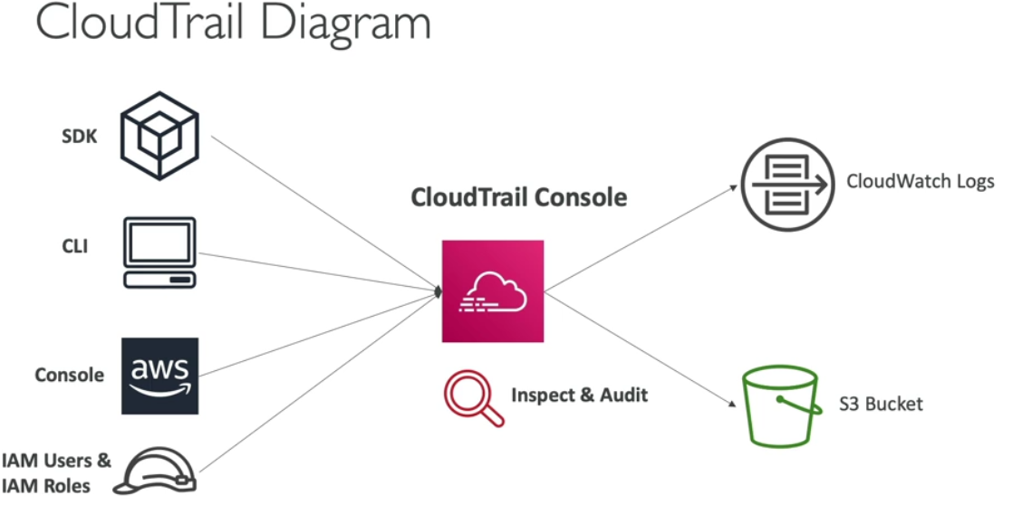

**CloudTrail Events**

* **Management Events:**
  + Operations that are performed on resources in your AWS account
  + Examples:
    - Configuring security (IAM AttachRolePolicy)
    - Configuring rules for routing data (Amazon EC2 CreateSubnet)
    - Setting up logging (AWS CloudTrail CreateTrail)
  + By default, trails are configured to log management events.
  + **Can separate Read Events (that don’t modify resources) from Write Events (that may modify resources)**
* **Data Events:**
  + By default, data events are not logged (because high volume operations)
  + Amazon S3 object-level activity (ex: GetObject, DeleteObject, PutObject): can separate Read and Write Events
  + AWS Lambda function execution activity (the Invoke API)

**CloudTrail Insights**

* CloudTrail Insights is a feature within AWS CloudTrail that **analyses your management events to identify unusual in your account**. Example-
  + inaccurate resource provisioning
  + Hitting service limit
  + Bursts of AWS IAM actions.
  + Gaps in periodic maintenance activity
* CloudTrail Insight analyses normal management events to create a baseline and then continuously analyses write events to detect unusual pattern.

**CloudTrail events retention**

* Events are stored for 90 days in CloudTrail.
* To keep events beyond this period, log them iso S3 and use Athena.

**CloudWatch vs CloudTrial**

* CloudWatch is a monitoring service for AWS resources and applications. CloudTrail is a web service that records API activity in your AWS account.
* CloudWatch monitors applications and infrastructure performance in the AWS environment. CloudTrail monitors actions in the AWS environment.

**AWS X-Ray**

AWS X-Ray helps developers analyze and debug production, distributed applications, such as those built using a microservices architecture.

With X-Ray, you can understand how your application and its underlying services are performing to identify and troubleshoot the root cause of performance issues and errors.

**AWS X-Ray advantages**

* Troubleshooting performance (bottlenecks)
* Understand dependencies in a microservice architecture
* Pinpoint service issues
* Review request behaviour
* Find errors and exceptions
* Are we meeting time SLA?
* Where I am throttled?
* Identify users that are impacted

**AWS Code Guru**

* An ML-powered service for automated code reviews and application performance recommendations
* Provides two functionalities
* **CodeGuru Reviewer**: automated code reviews for static code analysis (development)
* **CodeGuru Profiler**: visibility/recommendations about application performance during runtime (production)

**CodeGuru Reviewer**

* Identify critical issues, security vulnerabilities, and hard-to-find bugs
* Example: common coding best practices, resource leaks, security detection, input validation
* Uses Machine Learning and automated reasoning
* Hard-learned lessons across millions of code reviews on 1000s of open-source and Amazon repositories
* Supports Java and Python
* Integrates with GitHub, Bitbucket, and AWS CodeCommit

**CodeGuru Profiler**

Amazon CodeGuru Profiler helps developers find an application's most expensive lines of code(issue in code) by helping them understand the runtime behaviour of their applications, identify and remove code inefficiencies, improve performance, and significantly decrease compute costs.

* Helps understand the runtime behaviour of your application
* Example: identify if your application is consuming excessive CPU capacity on a logging routine
* Features:
  + Identify and remove code inefficiencies
  + Improve application performance (e.g., reduce CPU utilization)
  + Decrease compute costs
  + Provides heap summary (identify which objects using up memory)
  + Anomaly Detection
* Support applications running on AWS or on- premise
* Minimal overhead on application

**AWS Services Health Dashboard**

AWS Health Shows all regions, all services health, service events, planned changes, and account notifications to help you manage and take actions.

To view it, sign in to account and we would be able to see it.

* Shows all regions, all services health
* Shows historical information for each day
* Has an RSS feed you can subscribe to
* <https://status.aws.amazon.com/>

**AWS Personal Health Dashboard**

Personal Health Dashboard gives you a personalized view into the performance and availability of the AWS services underlying your AWS resources.

* AWS Personal Health Dashboard provides alerts and remediation guidance when AWS is experiencing events that may impact you.
* While the Service Health Dashboard displays the general status of AWS services, Personal Health Dashboard gives you a personalized view into the performance and availability of the AWS services underlying your AWS resources.
* The dashboard displays relevant and timely information to help you manage events in progress and provides proactive notification to help you plan for scheduled activities.
* Global service https://phd.aws.amazon.com/
* Shows how AWS outages directly impact you & your AWS resources
* Alert, remediation, proactive, scheduled activities

**Personal Health Dashboard does not have RSS feed.**